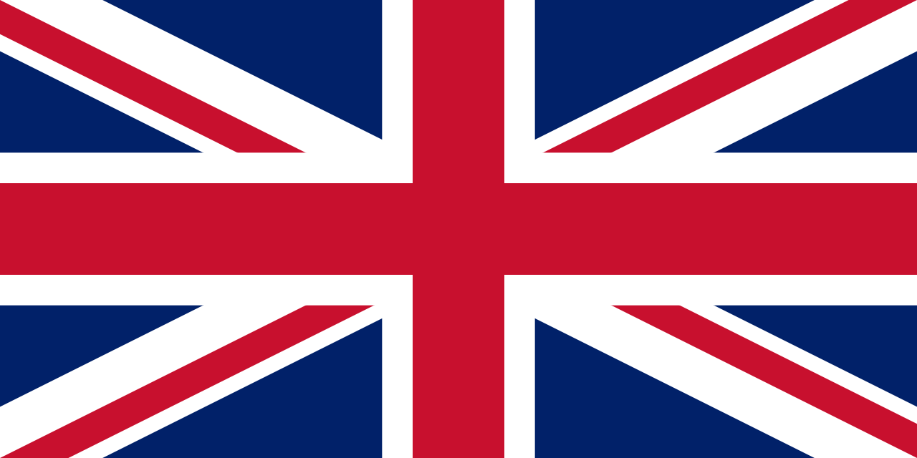
Pirates

Physical features | Human features
Beach  Cliff  Coast  Forest  Hill  Mountain  Sea  Ocean  River  Cave  Valley | City  Town  Village  Factory  Farm  House  Castle

Key people
Captain Cook 1728-1779
He was born in Marton and was a famous explorer, navigator and Captain, He was the first person from Europe to discover Australia and the first person to sail all the way around New Zealand.
Black Beard 1680-1718
His real name was Edward Teach and he was married 14 times! His favourite drink was rum mixed with gun powder. He was only a pirate for 2 years before he was caught and has his head chopped off.
William Kidd 1645-1701
He started off as a well-respected sailor but was forced to be a pirate by his crew. He is the only pirate known to bury his treasure. He was hanged for being a pirate.
Anne Bonney 1698-1782
As women weren’t usually allowed on ships she dressed up as a man and was an excellent fighter. She has friends with another female pirate called Mary read and married to a pirate called Calico Jack.
Black Bart 1682-1722
His real name was John Roberts but he changed it to Black Bart when he became a pirate. He loved to wear expensive clothes and jewellery even when he went into battle.

Continents | Oceans
Europe  Africa  Asia  Australia  North America  South America  Antarctica | Atlantic  Pacific  Indian  Southern  Arctic

England | 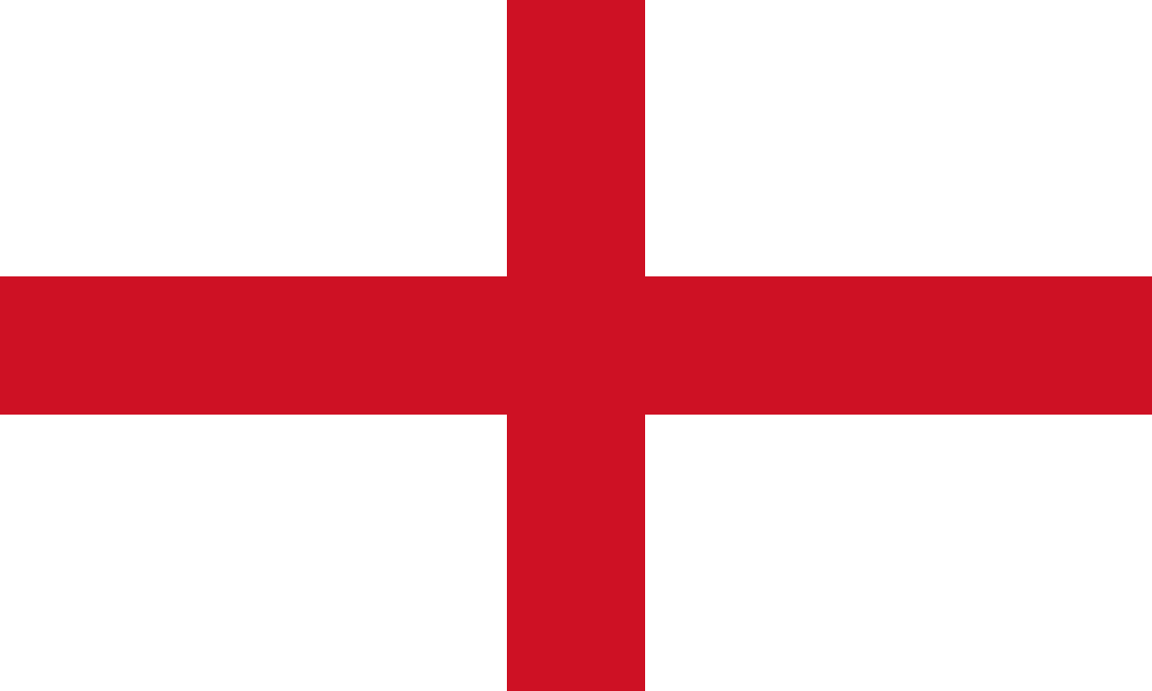  Flower - Rose  Capital- London  Patron Saint- Saint George
Northern Ireland | 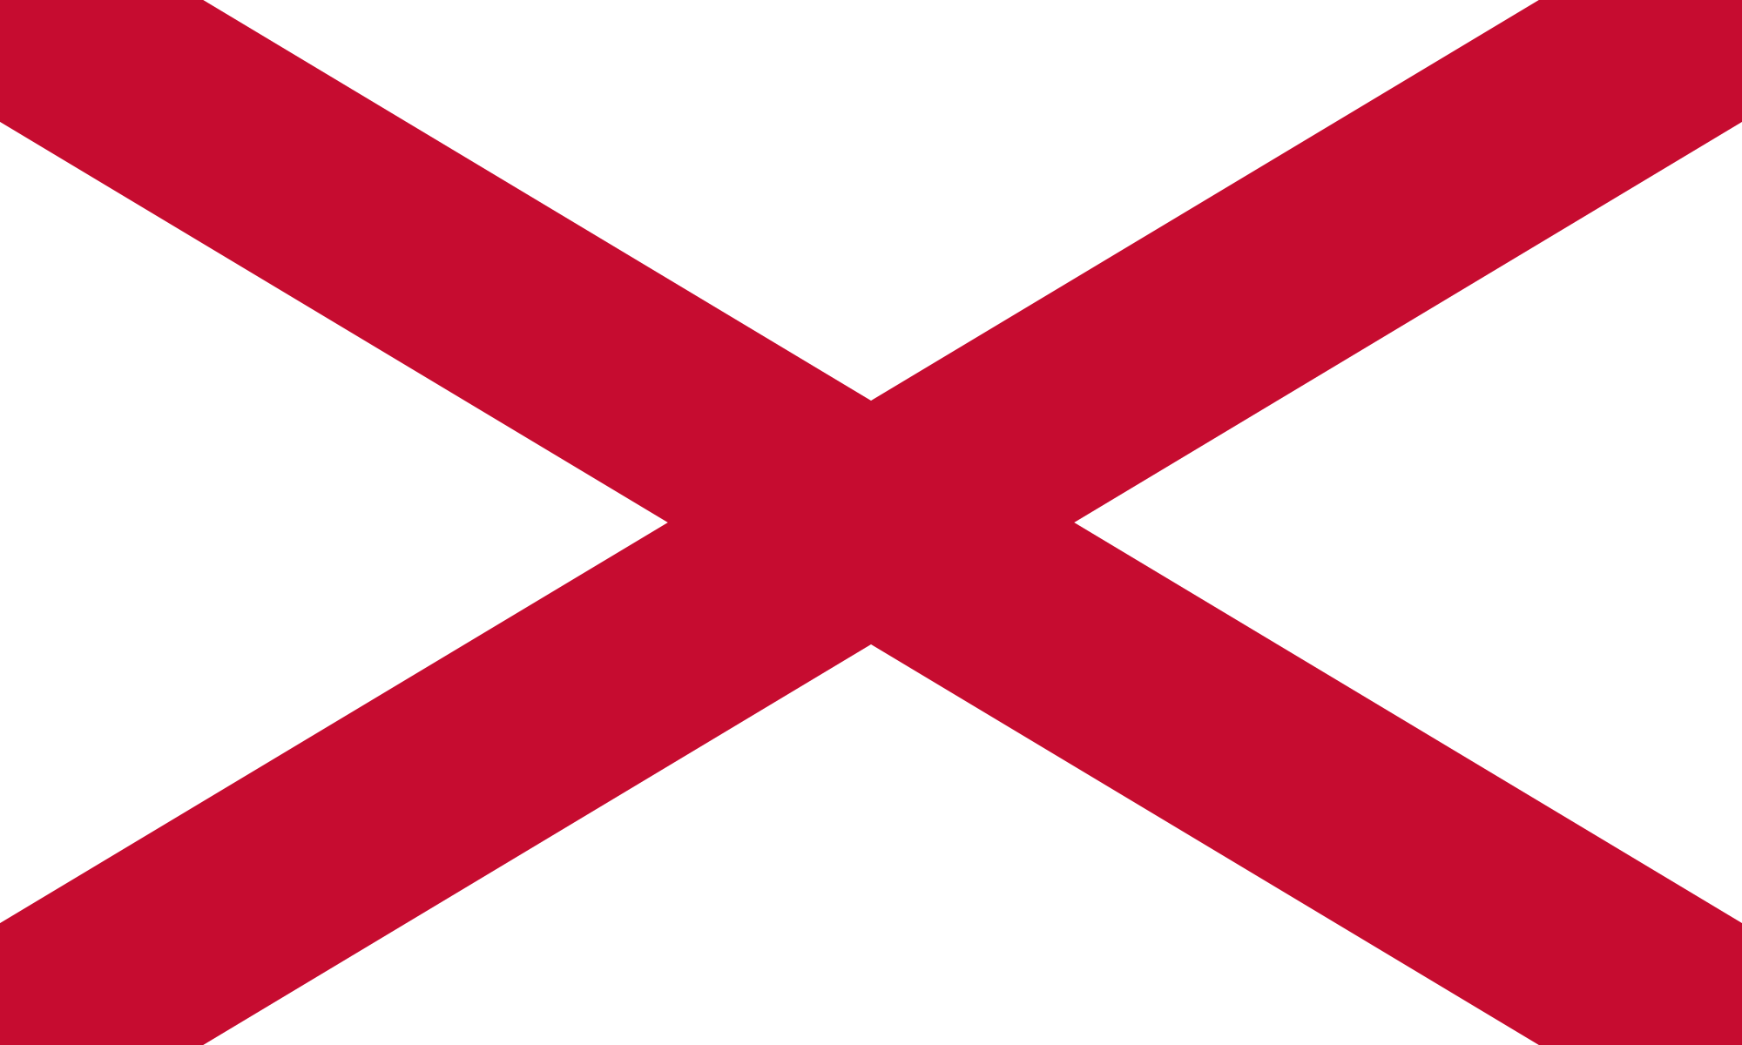  Flower - Shamrock  Capital- Belfast  Patron Saint- Saint Patrick
Scotland | 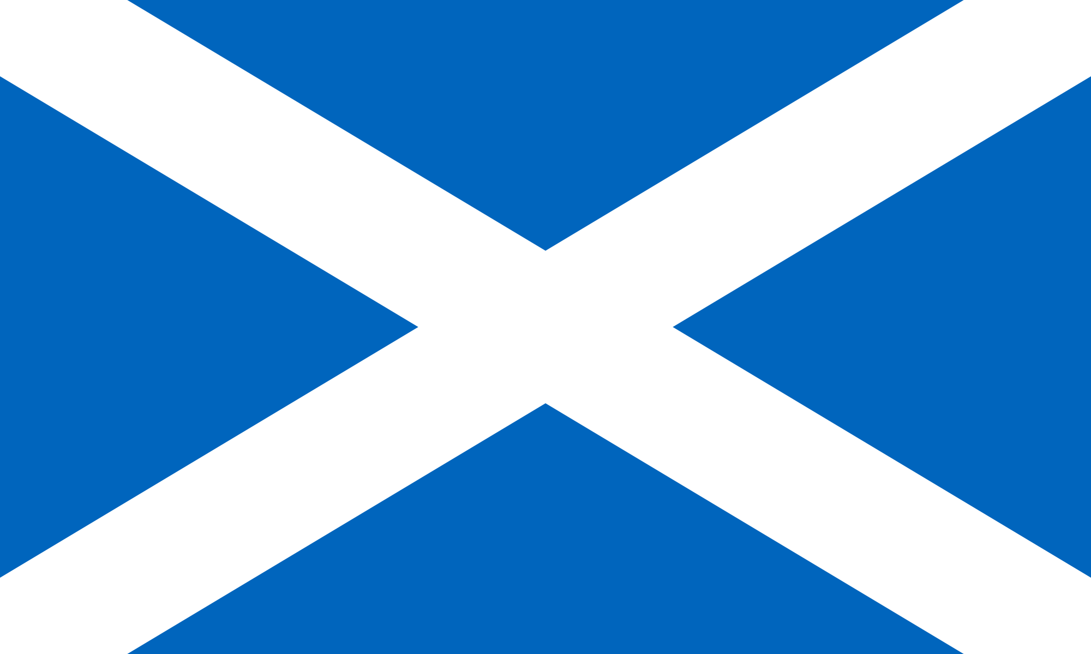  Flower - Thistle  Capital- Edinburgh  Patron Saint- Saint Andrew
Wales | 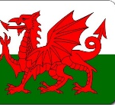  Flower – Leek and daffodil Capital- CardiffPatron Saint- Saint David
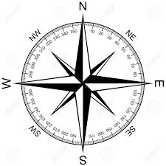
This is a compass. Sailors used these to help navigate when sailing at sea. They couldn’t always use maps because sometimes they were sailing to places no one had been before!
Pirates

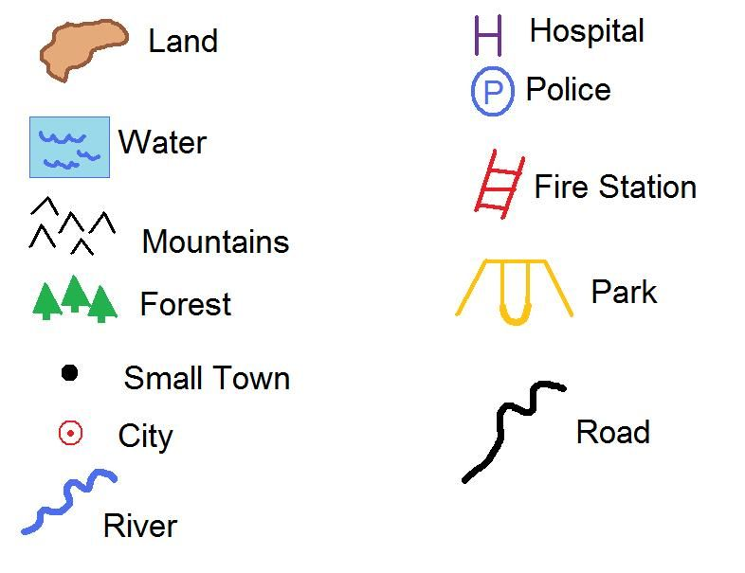

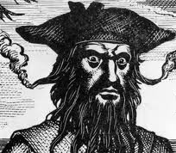
This is an example of a key for a map. Each symbol represents a physical or human feature.

