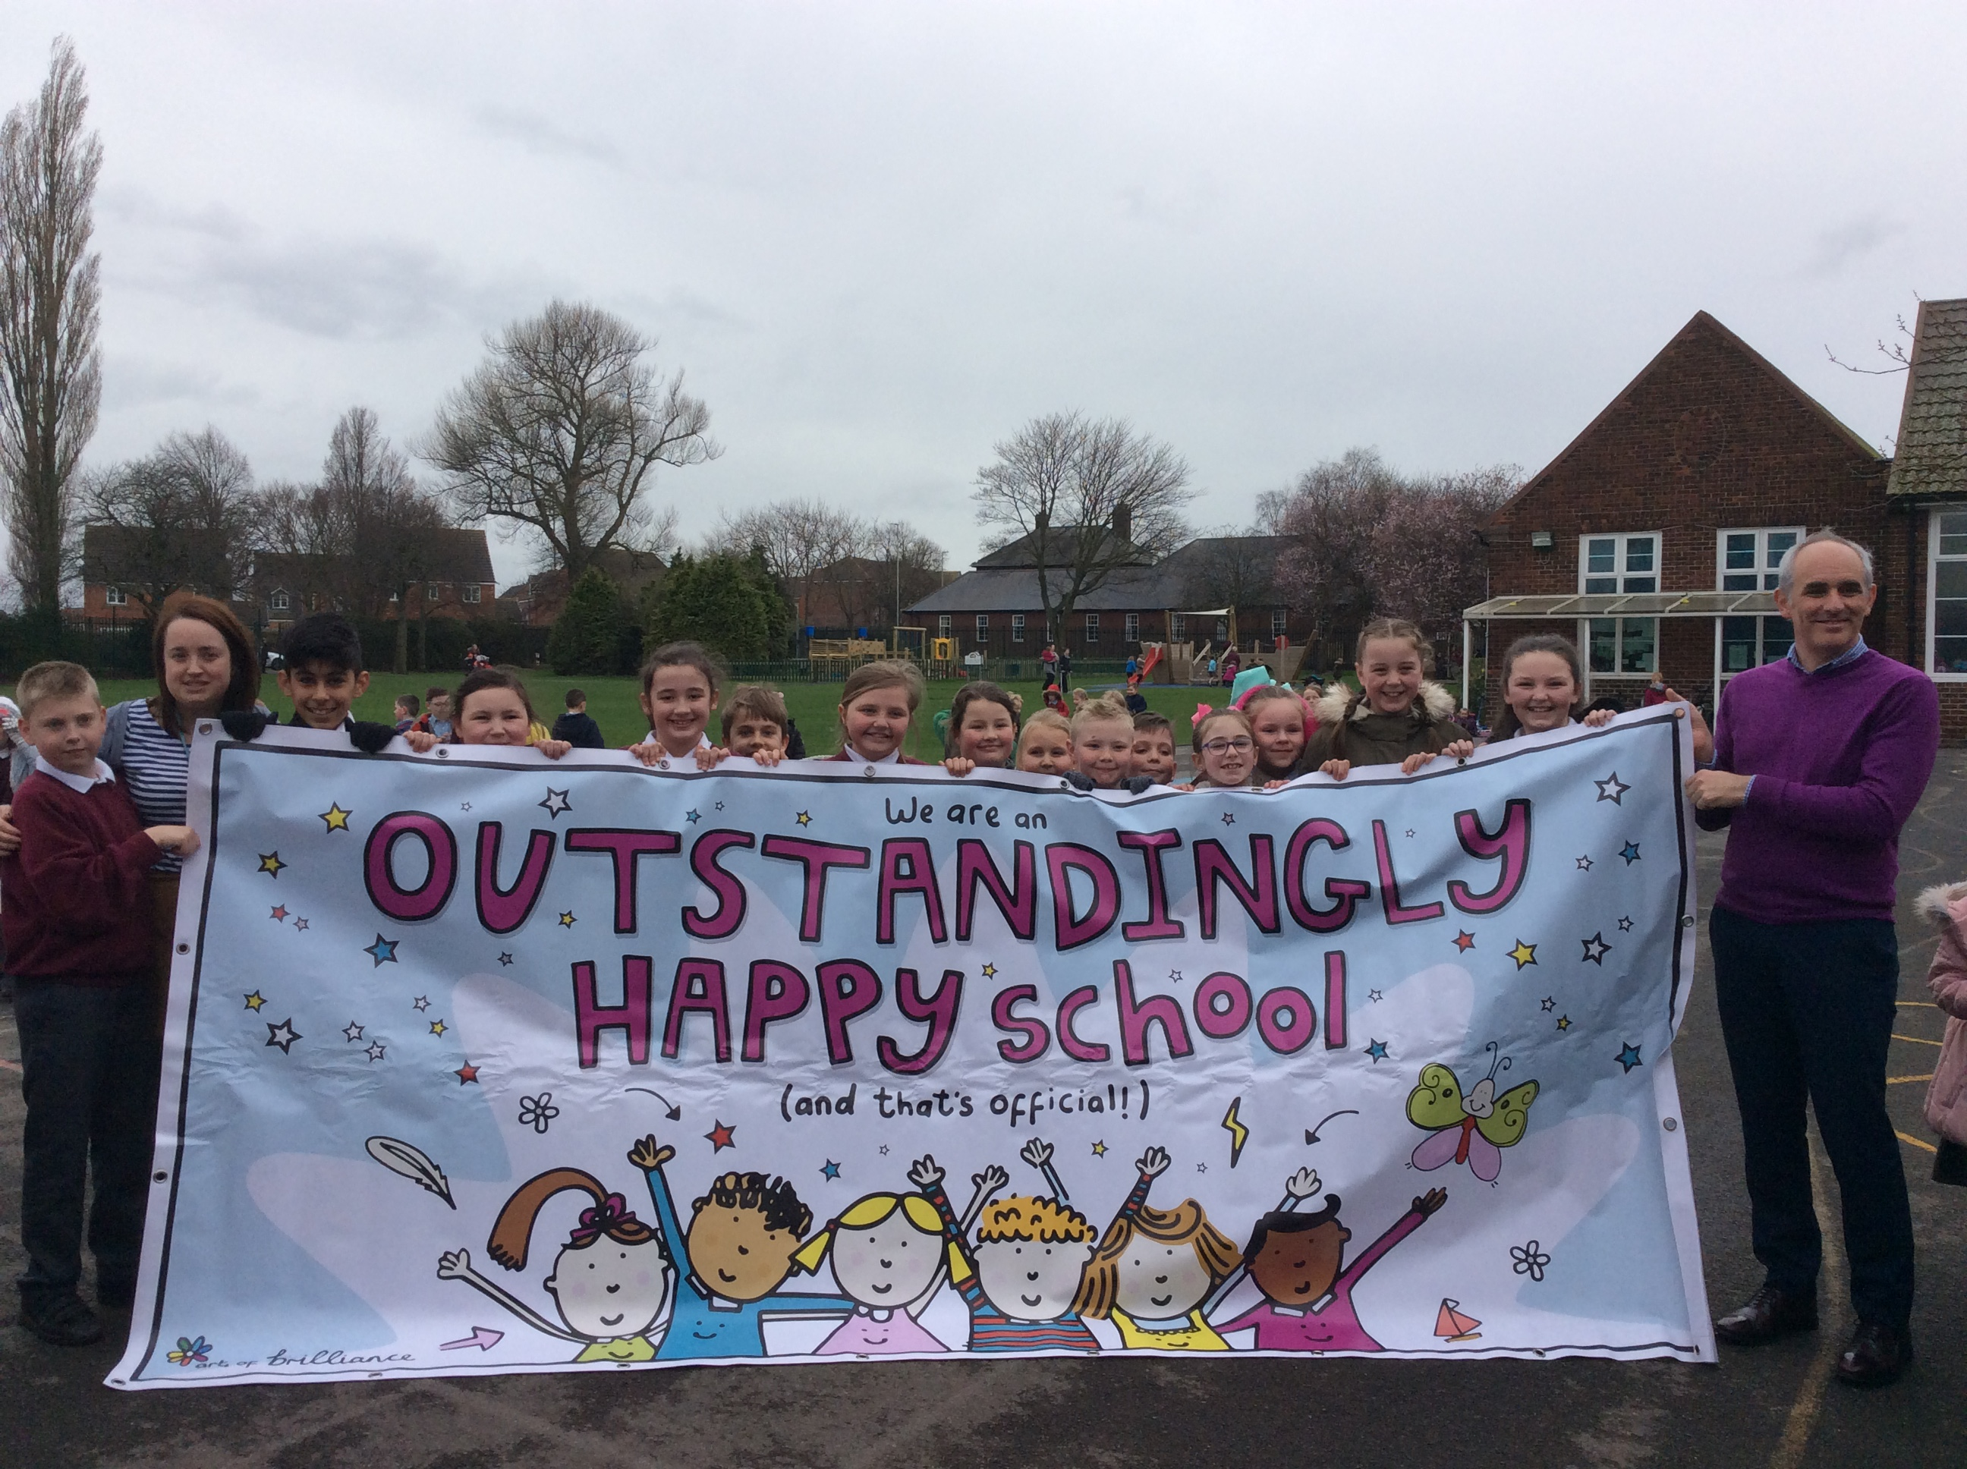

Welcome to

Billingham South Community Primary School

Dear Parents and Carers,

Thank you for taking the time to read our school brochure.

Billingham South Community Primary School is a wonderful place where we believe that all children should have the opportunity to achieve the best they possibly can. We pride ourselves in seeking to have excellent relationships with parents and families. We seek to provide an excellent education for all the children in our care.

Attending school is an important part of a child's development. Our aim is for the whole school to have an attendance rate of 95% or above each week. To celebrate our achievements, we have a special assembly each week, where we award the class in each Key Stage with the best attendance, with a certificate. The classes with the best annual attendance, at the end of the year, visit our ’Ice cream Parlour’.

If you would like any further information about our school, would like to visit or have any suggestions that would make our school brochure even better, please get in touch with me.

We have a superb website at Billinghamsouth.com Here you will find lots more information about Billingham South including photographs and reports of many of the opportunities available to the children and the latest OFSTED report.

Edwin Squire
Head Teacher

Table of Contents
Plan of Billingham South Community Primary School: page 3
Our School Ethos, Our School and Our School Office: page 4
School Hours: page 5
Admissions: page 6
School Organisation: page 7
Teaching Staff and Responsibilities: pages 8 and 9
Child Protection: page 10
Parents and School: page 11
The Curriculum in Key Stage One and Key Stage Two: pages 12 and 13
Curriculum Newsletters, Sex Education and Religious Education: page 14
The Curriculum in Early Years/ Foundation Stage: page 15
Assessment: page 16
Special Educational Needs and Disabilities (SEND): page 17
Excellence and Enjoyment: page 18
School Attendance Information: page 19
Illness and Emergencies, Medication: page 20
Behaviour Management: page 21
Our Dress Code: pages 22 and 23
Lost Property and Playground Rules for Everyone: page 24
Mobile Phones, Sweets and Other Valuables: page 25
Pupil Premium, Complaints, Concerns or Praise: page 25

Our School Vision
Everybody Prepared and Inspired to be the Best we can be.
Excellent Relationships.
Excellent Classrooms.
Hearts in Billingham and Eyes on the World.

Our School
Our school was built in 1930 and consists of two main sections, one for children from Nursery to the end of Year Two and one for children from Year Three to Year Six.
We are an Enhanced Mainstream School and have 10 places in a specialist class for children who have Cognition and Learning Needs and 10 places in our mainstream classes for children with Physical and Medical Needs. Places in our EMS are awarded by Stockton’s SEND panels and not through application to school.
We have a large site surrounded by purpose built playgrounds, playing fields, inner garden areas, a purpose built Early Years play area, an organic garden and a school pond.
Wheelchair access is provided through purpose-built ramps and automatic doors throughout the building. The school has sixteen classrooms including a nursery and our SB/IAC. We also have a stunning ICT suite with state of the art computers and an ipad for each child. We also have a specialised science room/kitchen and library.
We are committed to our children’s Health and Well Being. To assist with this we have a play therapy room and school counsellor and an Occupational Therapy suite with a full time OT teaching assistant who works on programmes designed by Future Steps.
The school is well supported by its Governing Body and by our “Friends of Billingham South” parents and teachers group. We are always looking to develop close community links and have very successful partnerships with Stockton International Riverside Festival, Billingham Environmental Link Project, Billingham International Folklore Festival and many other local community projects and events.
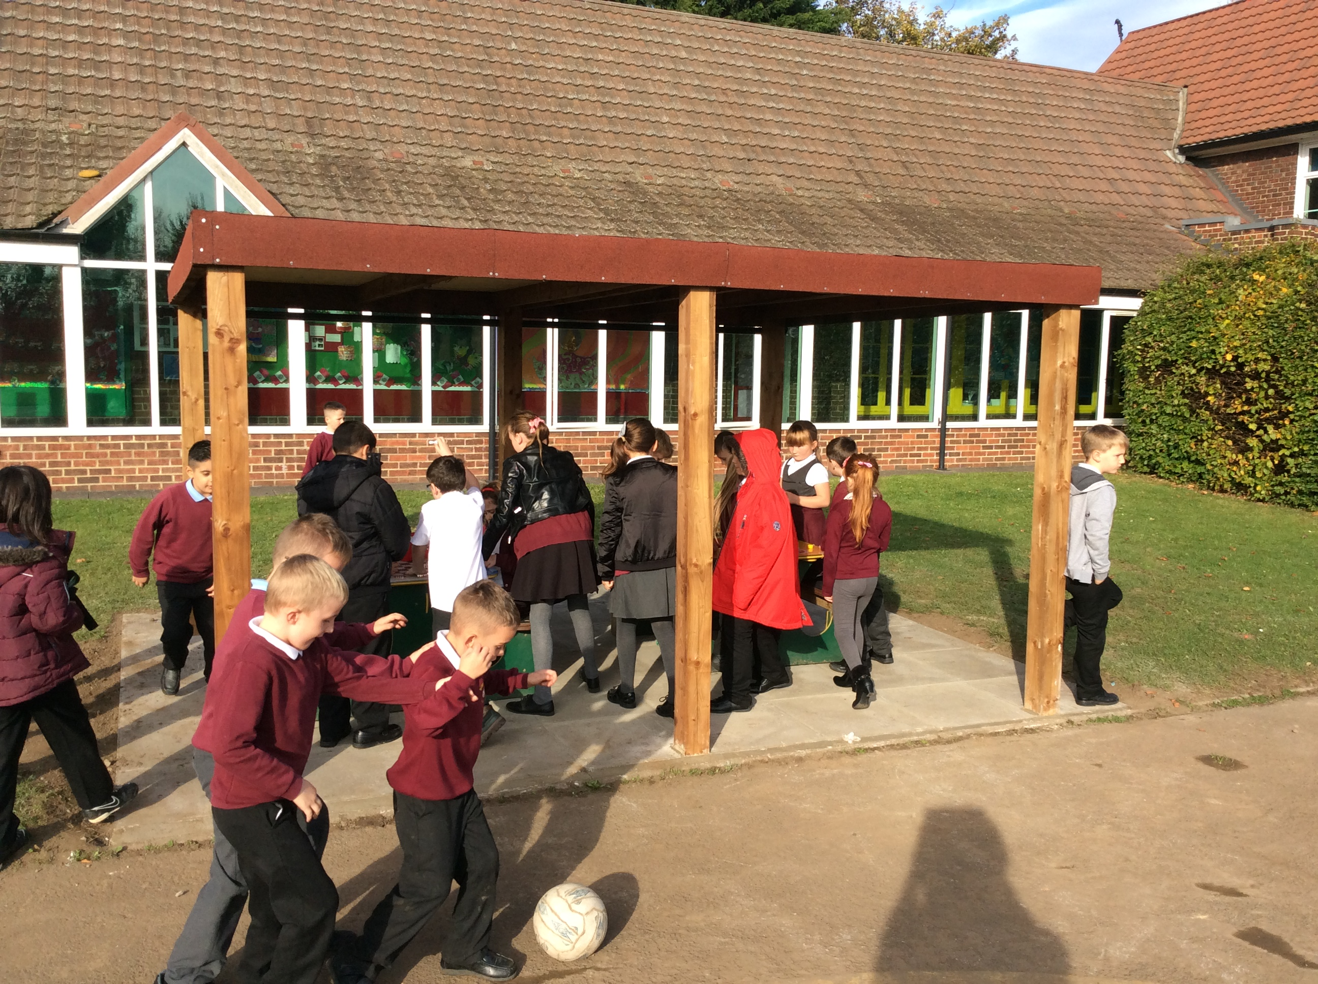
School Office
Our school office is open from 8:00 – 4:30 each day. The staff who work in our office are Mrs K Martin, Mrs J Stait and Miss H Best.
School Hours
Nursery (morning session) 8:50am – 11:50am
Nursery (afternoon session) 12:30pm -3:30pm
Key Stage One 8:50am -12:00noon (8:40 voluntary start for Mental Maths Y1 and 2)
1:00pm – 3:10pm (3:05 for YR)
Key Stage Two 8:50am – 12:15pm (8:40 voluntary start for Mental Maths)
1:15pm – 3:15 pm (no afternoon break)
Please Note:
Foundation Stage and Key Stage One children are not allowed onto the school site unattended.
Key Stage Two children are encouraged to arrive at school at 8:40am each day for their Mental Maths sessions. Children are not supervised by school staff until the school day begins at 8 40am.
School cannot be held responsible for accidents or incidents before either of the above stated times.

Admissions
Admission to School
Our admissions procedure is in-line with Stockton Borough Council policy. Children of school age will receive information from the local authority. Any child whose fifth birthday falls between 1st September and 31st August during this academic year may be admitted full-time to a Reception class. Further information and guidance on admission to full-time education can be accessed through Stockton Borough Council’s website.
Admission to Nursery
Our Nursery operates a flexible 15 hour provision for children at the age of three years. As detailed in the “School Hours” section of this brochure, four options are available for Nursery provision according to availability. Visits to look around our Nursery are encouraged and applications must be made direct to the school office. Once your application has been received, your child will go on our waiting list.
A place in our Nursery does not guarantee a place in our Reception class when your child reaches school age. You must still complete an admission pack, which you will receive from Stockton Borough Council.

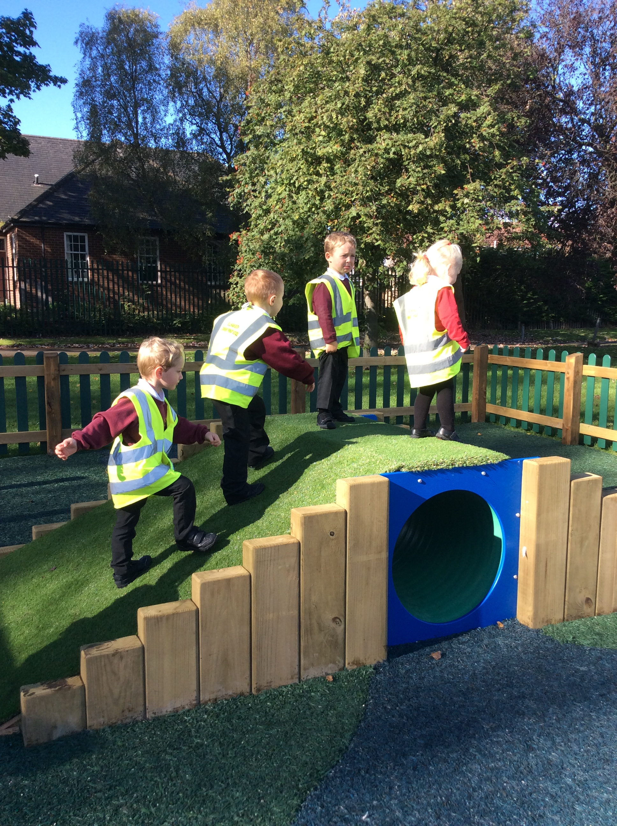
School Organisation
Early Years Foundation Stage/ Year One
Our EYFS consists of a Nursery with places for 65 children attending on a program of four different options and two reception classes where the maximum class size is 30.
We have three teachers operating in EYFS and a number of teaching assistants who are “key workers” attached to specific children. A team leader is in charge of this part of school.
Key Stage One and Two
The rest of our school is divided into two teams: Middle School which consists of Year Two, Year Three and Year Four children and Upper School for Year Five and Year Six children. Each team has a team leader who is in charge of that part of school.
There are two classes in each year group. Each class has a class teacher with at least one teaching assistant assigned to each year group. Teaching assistants are also used to support interventions across school that take place at assembly times.
Enhanced Mainstream Schools
Our EMS is part of an LA funded enhanced school providing tailored support for children who have cognition and learning difficulties and/or physical and medical need. The unit provides support for children across Key Stage One and Key Stage Two. We also have an EMS for children with Physical and Medical Needs. Children in this EMS access inclusion but our EMS Leader and a Medical Officer manage the provision of any additional need.
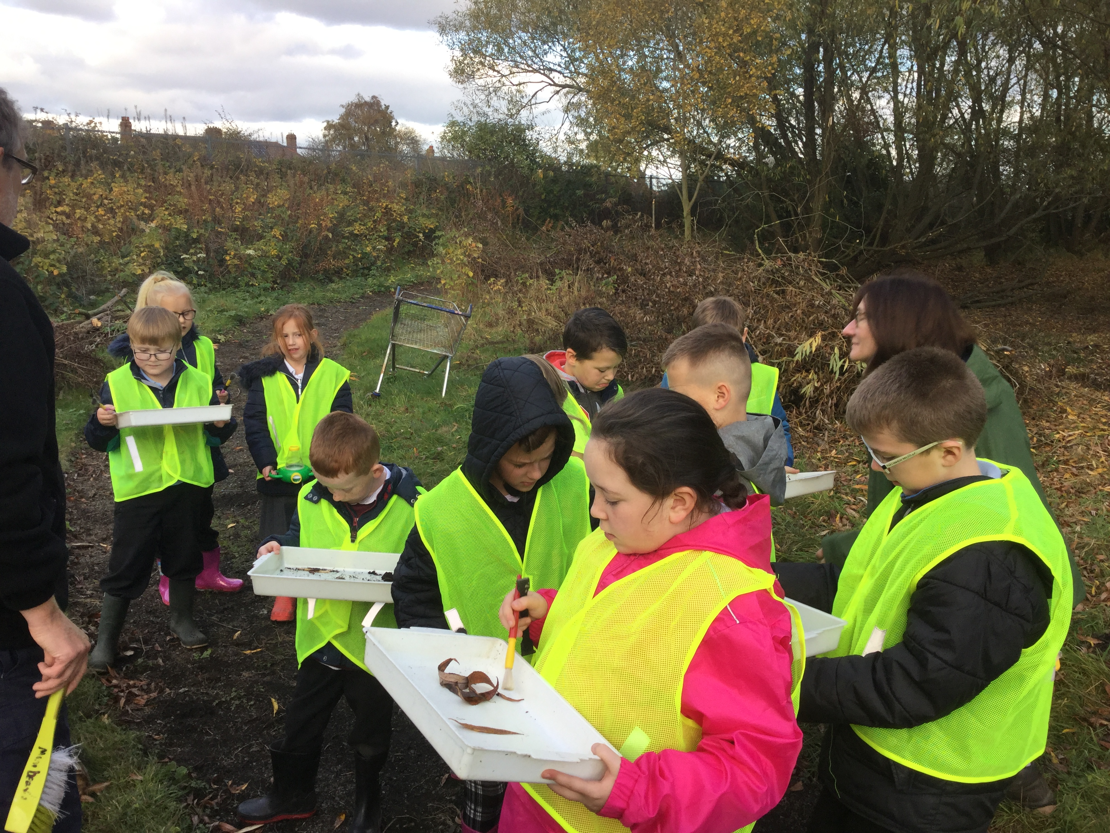

Teaching Staff and Responsibilities Part One
Head Teacher  Deputy Head Teacher  Foundation Stage Teaching Staff  Key Stage One Teaching Staff  Enhanced Mainstream School | Mr E Squire  Assessment Lead, Designated Lead Officer  Mrs K Hendy  Teaching and Learning Leader, CIOC officer, Designated Officer  Miss M Hind  EYFS and Y1 Leader, Designated Officer  Miss L Boyers  Design/Technology Subject Leader  Mrs C Wray  PE/Sport Subject Leader  Miss N Panagakis  Mrs C Charlton  Art Subject Leader  Mrs B Cooke  Music Subject Leader  Mrs K Hopes  SMSC Subject Leader  Mrs C Howe  Curriculum Co-ordinator  Mrs J Pawlett  SENCO, EMS Manager, EMS (C and L) specialist class teacher

Teaching Staff and Responsibilities Part Two
Lower Key Stage Two Teaching Staff  Upper Key Stage Two Teaching Staff  Cross Phase Teachers for Planning Preparation and Assessment Cover | Miss L Honour  English Subject Leader  Y2,3 and 4 Team Leader  Designated Officer  Miss K Hanson  RE subject leader  English Shadow and Dance Specialist  Mrs D Stewart  Geography subject leader  Maths Shadow Lead  Fundraising Leader  Miss A Hill  Shadow SMSC subject leader  Mrs H Jackson  Y 5 and 6 Team Leader,  Mathematics Subject Leader  Mrs A Flynn  Modern Foreign Language Subject Leader  Mr S Hindle  Miss J Robinson  History Subject Leader  Mrs Z Khan  Science Subject Leader  Mr D Dixon  Specialist Computing Teacher/ EMS teacher  ICT subject Leader  Mr S Jackson  Specialist Forest Schools

Staffing Structure September 2020
Year Group | Teachers | Teaching Assistants | PPA Cover
Nursery | Mrs Wray  Miss Panagakis | Mrs Hindmarsh  Miss Ward  Mrs Elwell  Miss Robinson (EMS) | Internal cover
Reception | Miss Hind  Miss Boyers | Mrs Exton  Miss Sherlock  Mrs Balharry (EMS)  Mrs Lannon-Russell (EMS) | Mr Coates/ Mr Jackson
Year 1 | Mrs Charlton  Mrs Hopes | Mr Coates  Mrs Ward (1:1)  Miss Millington (1:1) | Mr Coates/ Mr Jackson
Year 2 | Mrs Howe  Mrs Cooke | Mrs Robinson  Mrs Bannister | Miss Mowbray/ Mr Jackson
Year 3 | Mrs Stewart  Miss Hill | Mrs Marshall | Miss Mowbray/ Mr Dixon
Year 4 | Miss Honour  Miss Hanson | Miss Elcoat | Miss Mowbray/ Mr Dixon
Year 5 | Mrs Khan  Miss Robinson | Mrs Wynn | Miss Mowbray (PEAK coach)/ Mr Dixon
Year 6 | Mrs Jackson  Mrs Flynn  Mr Hindle | Mrs Wilson  Mrs Lawman (1:1)  Miss Miller (1:1) | Mrs Wilson (PEAK coach) / Mr Dixon
EMS/P | Mrs Pawlett | Mrs MacDermid  Mrs Smith  Mrs Miller  Mrs Newall  Miss Thomas (OT) | Mrs MacDermid  Mrs Smith/ Mr Dixon

Mrs Garbutt – Reading Assistant Y1-5
Miss Miller – Y4/5 afternoon TA
Mrs Imlah - PSA
Child Protection

Parents and carers should be aware that the school has a duty of care to take reasonable action to ensure the welfare and safety of all pupils. In cases where school staff have reason to be concerned that a pupil may be subject to neglect or abuse of any kind they will report it to Mr Squire, Mrs Hendy, Miss Hind or Miss Honour and they will seek further advice by following child protection procedures.

If you should have a concern about a child you can also phone it through to the Safeguarding Hub at 01642 130080

OUR PARTNERS
ABC Counselling and Therapy
Brilliant Club
Billingham PCSOs
Derwent Hill
Digital Creatives (ICT)
Durham County Cricket Club
Education5 (Attendance Services)
Future Steps (Occupational Therapy)
Kalma Baby (Yoga)
North Tees Speech and Language Service
Pam Gartland Safeguarding First
PEAK (PECS programme providers)
Pegasus (Educational Psychology)
Pobble
ScoutEd (Outdoor Learning)
Shakespeare Schools Festival
Stockton SCITT
Stockton Riverside College
Stockton SSCO (Sports Partnership)
Stockton SEND department
Stonewall (SMSC Trainers)
Tees Active
Tomlinson Hall (Local Business Link)
Wheel Education

And thanks to Jayne Durham (Table Tennis Coach) and Colin Leckonby (Balance Bikes Coach)

Parents and School
If you are considering sending your children to Billingham South Community Primary School you should contact the school office to arrange an appointment. Mr Squire will be pleased to meet with you, conduct you on a tour of the school and answer any questions you may have.
Mr Squire and Mrs Hendy can be contacted on the phone, via email or through a direct appointment made at the school office.
We have two formal open evenings each year when you can discuss your child’s progress with their teacher. At these meetings you will receive a mini-report about your child’s progress. At the end of the academic year, you will receive a full report on your child’s progress. Prior to any children starting in our Nursery or Reception class, we hold meetings for parents so they can receive any relevant information.
If you would like to meet with a class teacher for any reason, please contact one of the adults on our entrances. Alternatively, please phone or visit the school office. We will ensure you get a prompt response.
Our school website (billinghamsouth.com) is updated regularly and provides parents with a full range of information about school and current events. We also have a Twitter account (@billinghamsth) which is regularly updated. Our Early Years children all have an e-portfolio which their parents can view. We have a school e-mail address if you want to contact us that way.
We also operate a school messaging service (School PING) to keep parents up to date. All we need is a mobile phone number to ensure that you always have up-to-date information.
We have a parents/staff group called Friends of Billingham South (fobs). This group also run a facebook page which contains all the latest information about school. We recommend all parents get involved with fobs and follow this facebook page.
Please Note- It is essential that we have 3 current contact phone numbers so that in the case of any emergency we are guaranteed of being able to contact you. Therefore, please ensure that when you change your mobile phone, you provide school with the new number.
For your child’s health and safety school should be able to contact someone on this list at all times.

The Curriculum in Key Stage One and Two
Every pupil at Billingham South Community Primary School follows the recommendations of National Curriculum’s Statutory Programmes of Study as they progress into Key Stage One and Two:
Our curriculum has been designed by our staff to maximise opportunities to learn and demonstrate our 5 school values (happiness, quality, responsibility, quality and courage).
All children take part in daily English lessons. We use the “Read,Write Inc” scheme to ensure that phonics are taught in a systematic way until children have the skills required to decode and spell words to the required standard. As children get older, we also use “Big Write” to give children a chance to write at length for a purpose.
All children take part in daily Maths lessons which concentrate on number work; shape, space and measures and data handling skills. Children are also encouraged to use their mathematical skills and knowledge to solve “Rich Mathematical Tasks”.
In Science, pupils learn about Living Things, Materials and their Properties and Physical Processes. They also learn the skills of investigation and experimenting so that they can become independent learners and make discoveries of their own.
In P.E. children have lessons in gymnastics, dance, and games throughout Key Stage One and Two. We also have a full programme of swimming lessons. Children in Year 5 receive coaching in table tennis and there are a range of opportunities in competitive sports such as cross-country running, football, trampoline and cricket. Some of our PPA cover is taught alongside PEAK specialist PE teachers who bring expertise in Sport. We also offer Computing and Forest Schools experts to enhance our exciting curriculum.
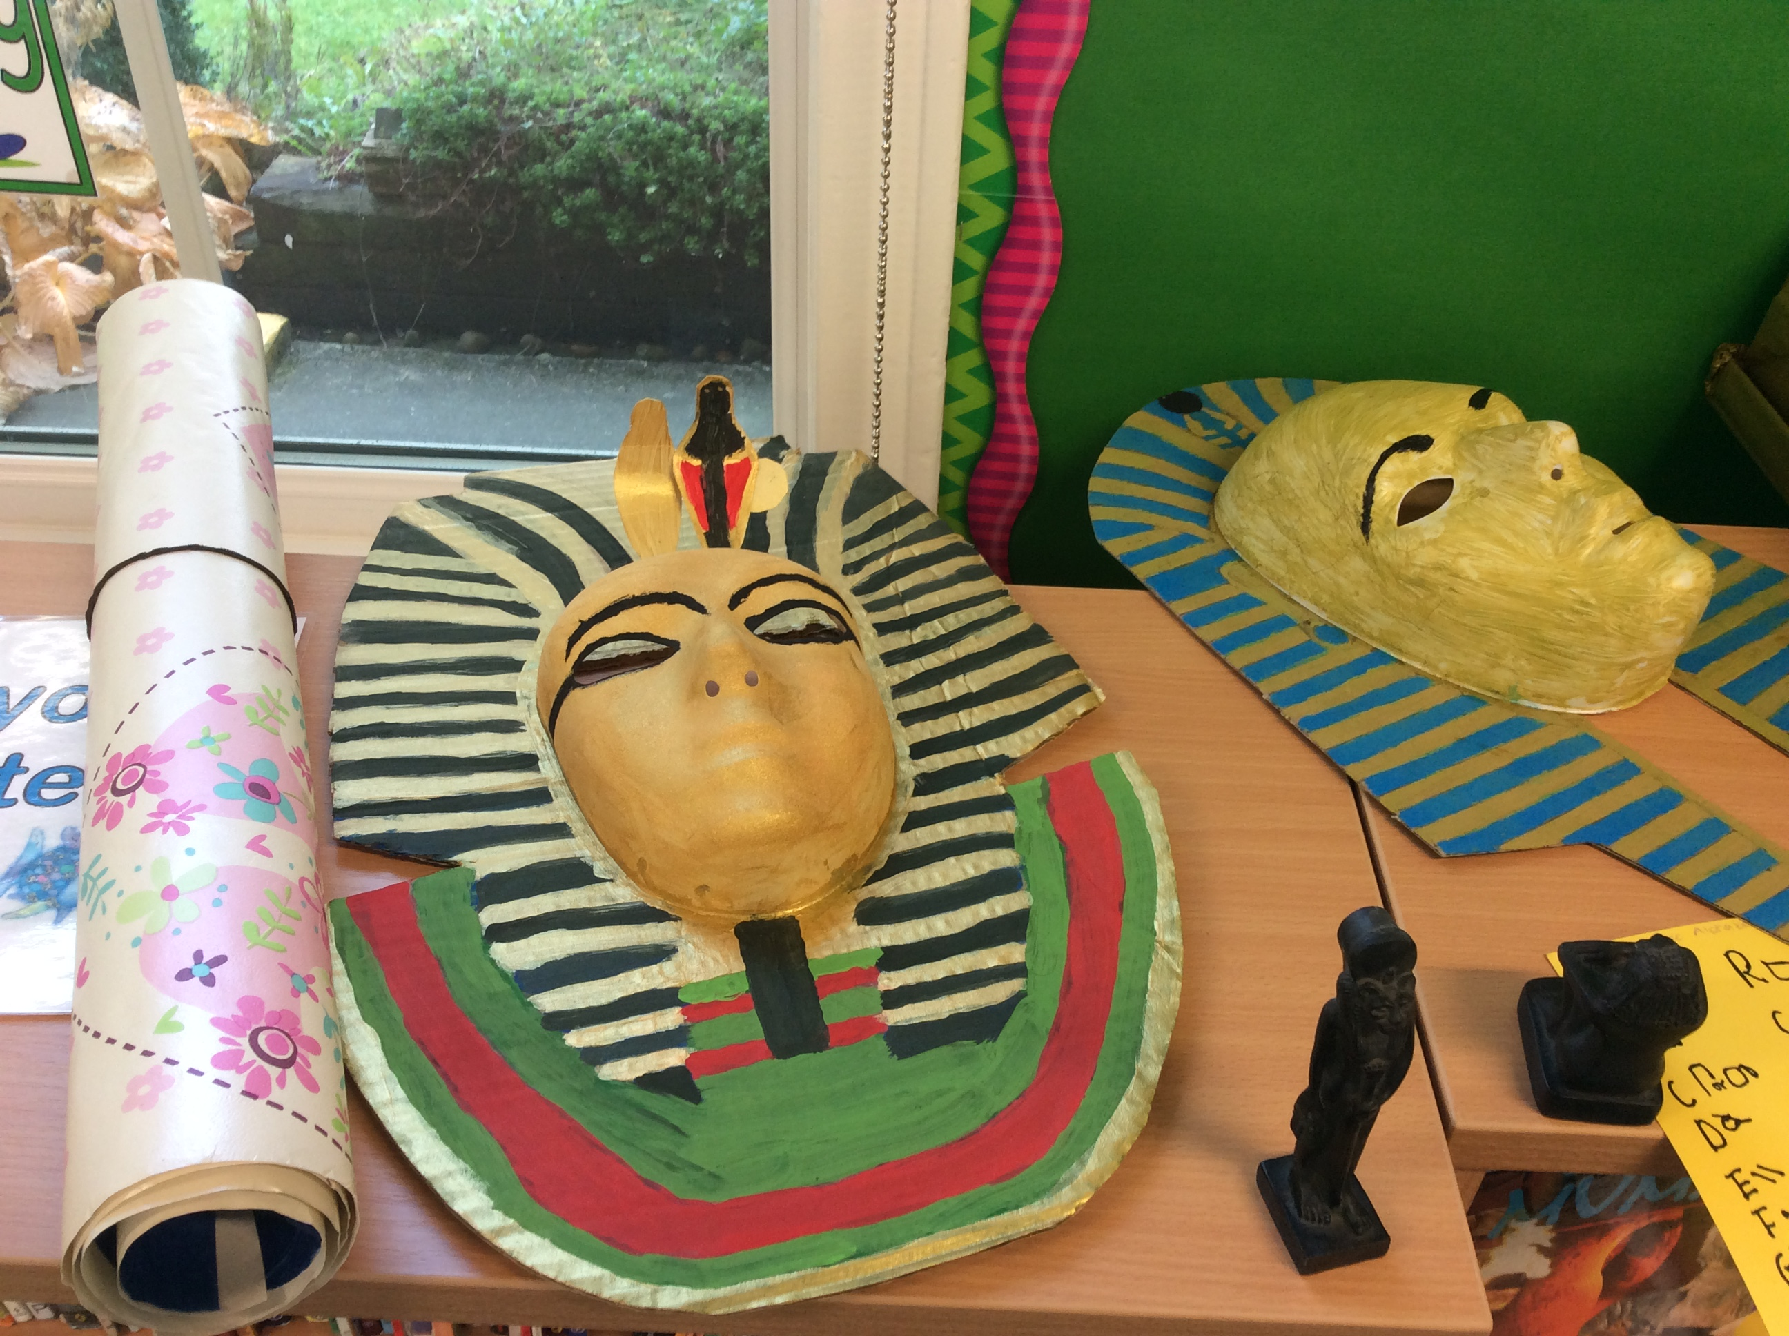
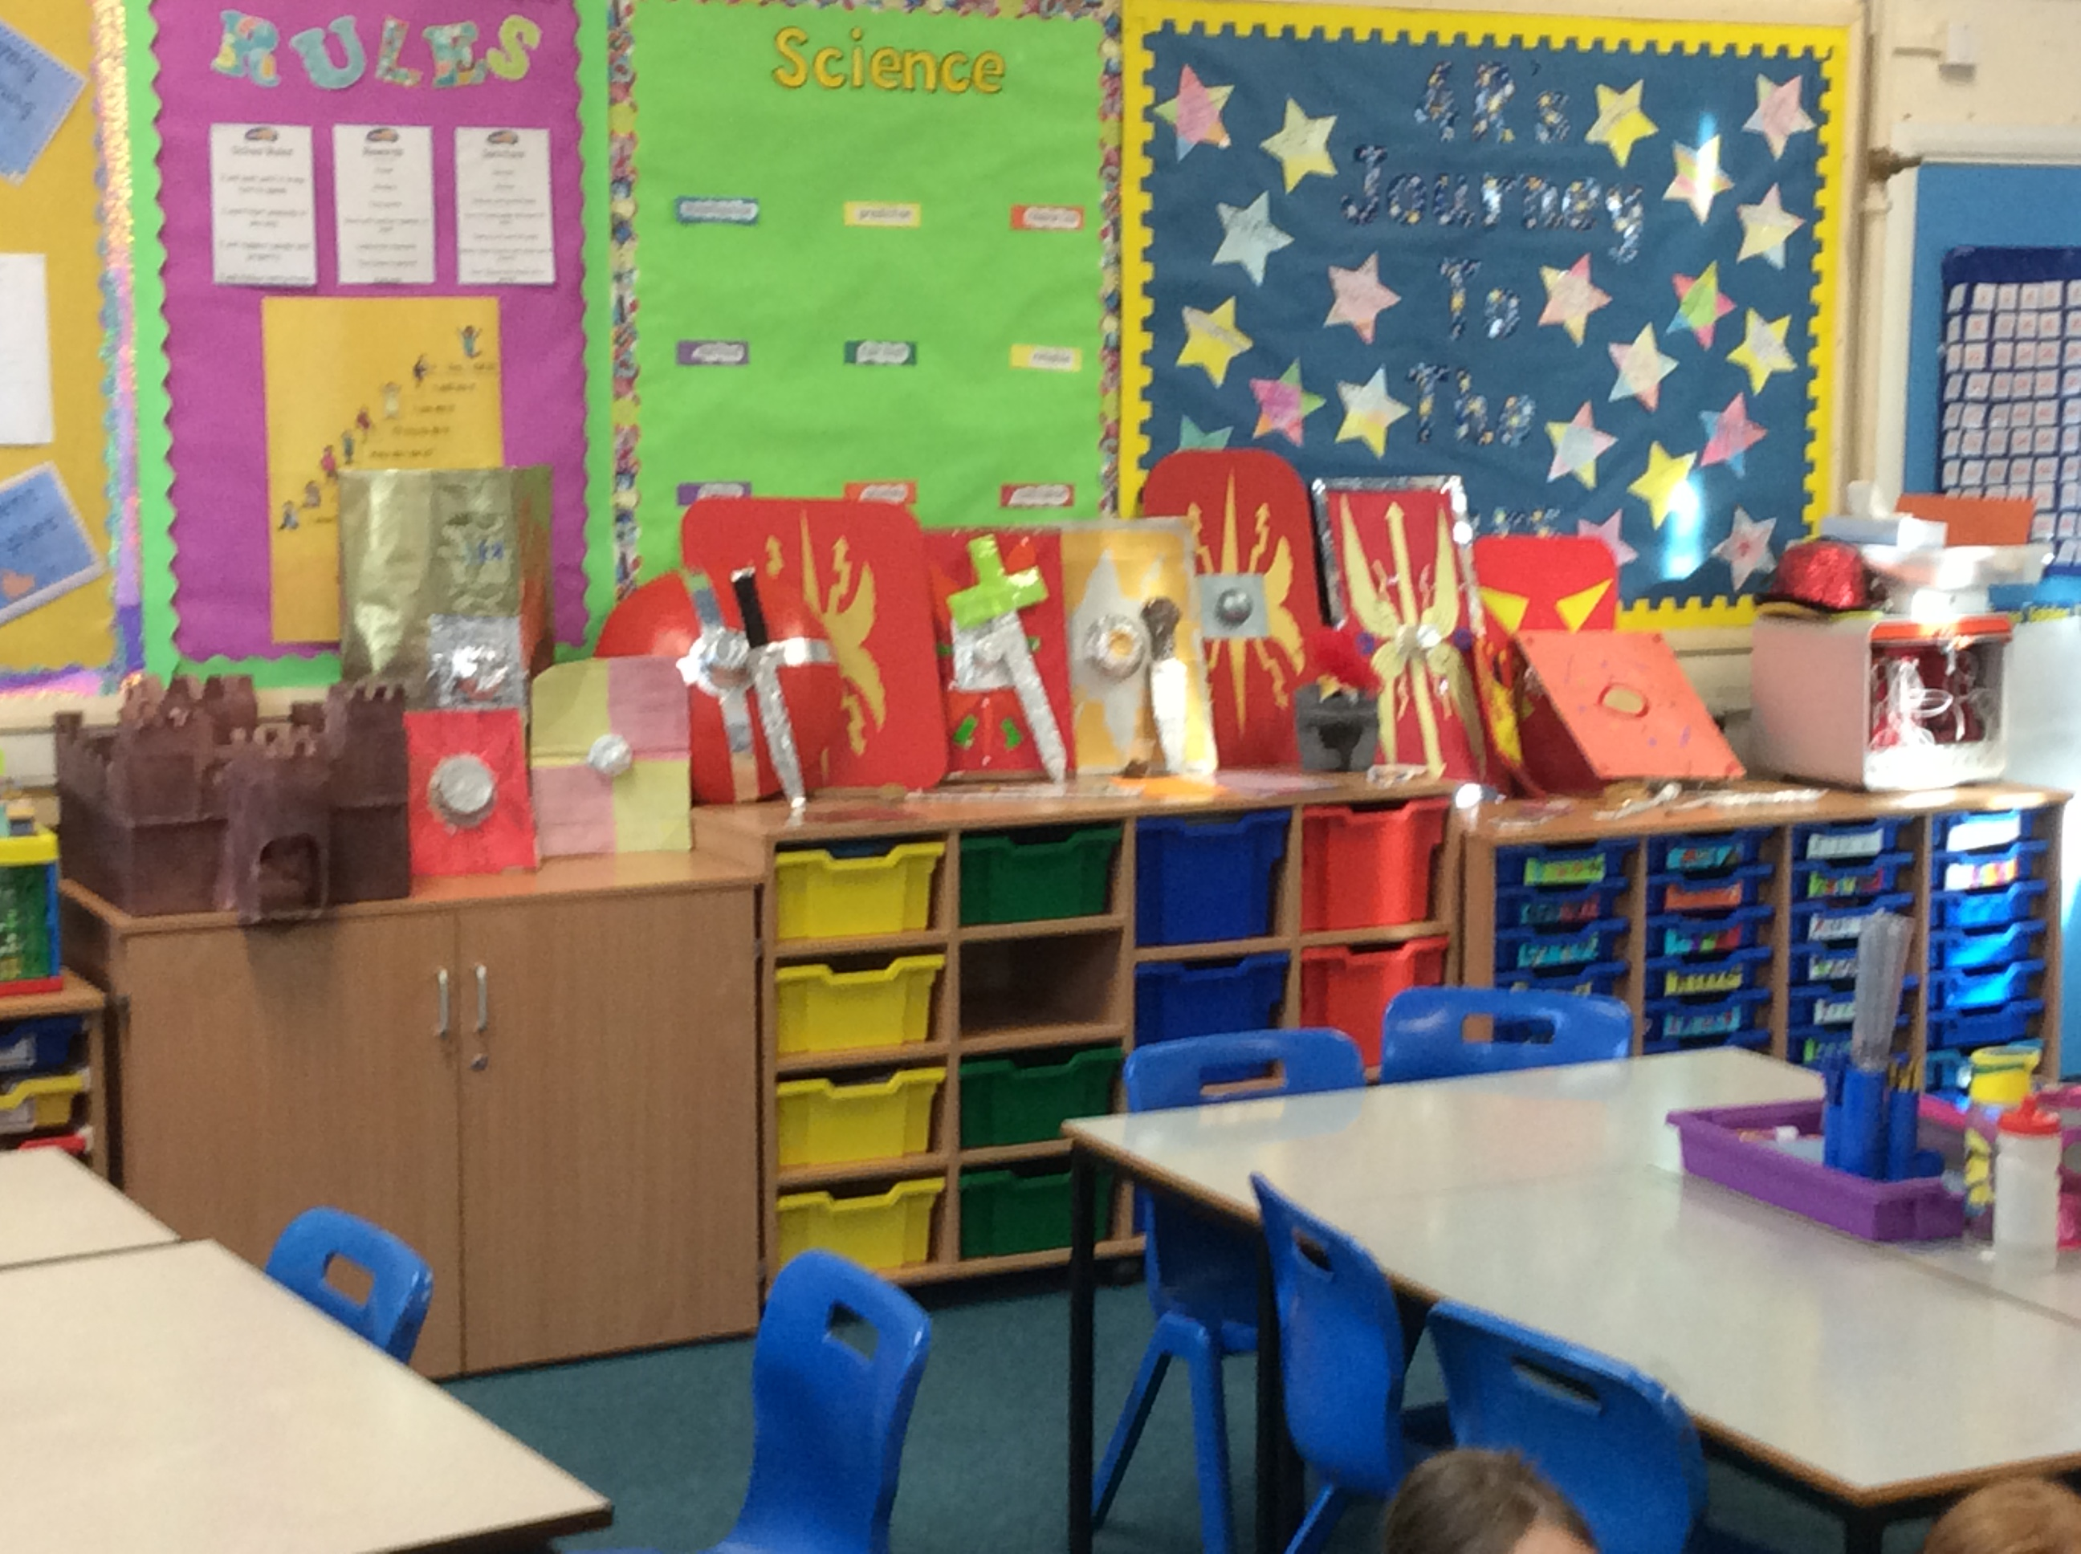
Examples of work from across school

In computing lessons, the children are taught the skills of programming, communicating and using computers in presentations. These take place in our computer suite which is fully equipped with state of the art PCs. Pupils also have access to a range of other technology including class sets of iPads. Cameras are also available.
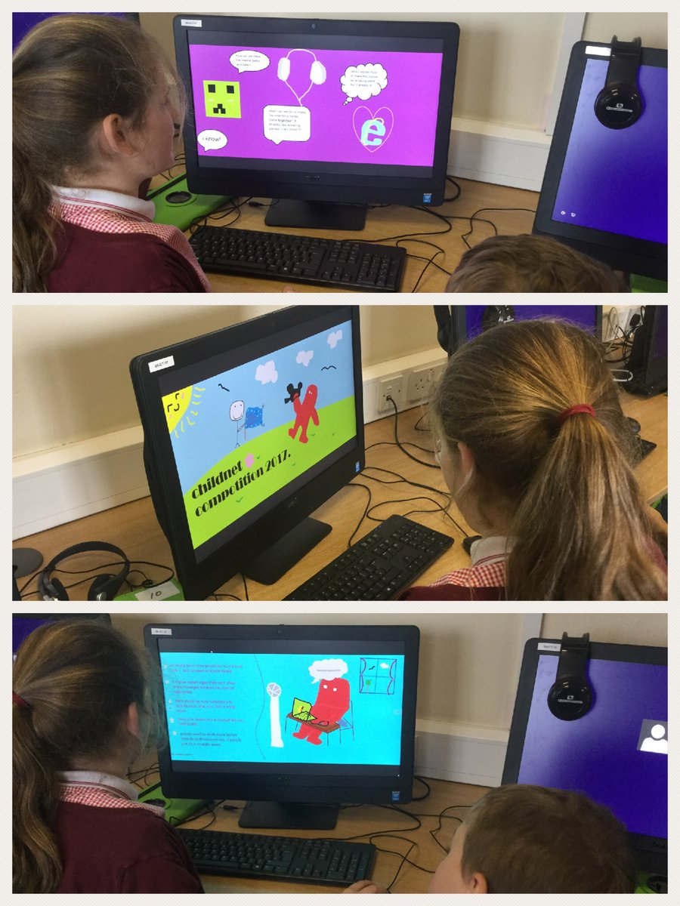
Our ICT Suite has state of the art ICT equipment
In PSHE, the school follows the Dimensions programme and also supports pupil’s Social, Moral, Health and Cultural needs in partnership with a number of local and regional programmes and schemes.
Modern Foreign Language our pupils learn is French.

OUR PLEDGE FOR YOUR CHILD

While your child is at Billingham South we will:

Keep them safe and support you in keeping them safe.

Prepare them well for the next step in their learning and help them make at least expected progress.

Teach them an exciting curriculum in stimulating learning environments.

Give them the opportunity to learn the values of happiness, courage, resilience, responsibility and quality.

Encourage excellent behaviour with consistent approach for each child.

Look after your child’s emotional well being.

Ensure you are well informed about your child’s learning, progress and behaviour.

Give them the opportunity to perform in the arts and sports.

Give them plenty of opportunity to learn outdoor skills and gardening.

Give them as much opportunity as possible to learn to swim 25 metres and learn to ride a bike.

Identify and provide support with Special Educational Needs as early as possible.

Ensure an inclusive approach for children in our EMS classes including the opportunity for integration or a “Preparation for Adulthood” curriculum.

Encourage them to take risks in challenging but secure settings.

CORONAVIRUS RESPONSE

- Our curriculum has been based on 5 key values: Happiness, Resilience, Courage, Trust and Quality. Because of our successful delivery of our curriculum (as evidenced by monitoring up to March 20th) our curriculum restart will also be based on these key values. However, we will be encouraging the new value of Responsibility to phase in to replace Trust. Trust is embedded in our pupils and we believe that responsibility will play a key part in rebuilding our society.

- HAPPINESS – We will take care of our pupils’ well-being by adapting our day when necessary. We will use every tool, resource and technique at our disposal to ensure pupil happiness.

- RESILIENCE – Our pupils have lived through an unprecedented time. We will remind them of the importance of resilience and a growth mindset. We will encourage the rebuilding of this value where necessary by ensuring clear, safe routines and structures to reassure and strengthen them.

- COURAGE – Starting back at school may be difficult for some. Courage will be encouraged through realistic challenge and risk-taking in a supportive environment. Once pupils are ready, we will conduct assessments so that we can identify lost learning and then make plans to address this.

- RESPONSIBILITY – Everyone has had different experiences during lockdown. But we will rebuild a safe, secure and happy community, society, nation and world by taking responsibility for our own actions. We will encourage responsibility by offering as much opportunity as possible to give children the chance to take responsibility for jobs, behaviour, actions and work.

- QUALITY – Returning to our best requires that we give our best. Our whole community needs to give our best for the children and the children need to give their best too. Well matched work following careful assessment will ensure the children can get back up to pace with their learning at the earliest possible time. Quality from everyone is expected.

Curriculum Newsletters
Further information about the curriculum is sent to all parents at the beginning of each term. This information allows parents to keep up-to-date with their child’s learning whilst enabling them to support their children with school work at home.
Sex and Relationships Education
We emphasise the importance of developing self-esteem and recognising the needs and feelings of others. Children are encouraged to develop an understanding of their own emotional development. They are also taught how to approach the different personal relationships they encounter as they get older. SRE is taught as part of the Dimensions curriculum. If parents have any questions about Sex and Relationships Education or want to view any of the resources used in class, they are welcome to make an appointment at the school office.
Religious Education and Assemblies
In R.E. we follow the Stockton Agreed Curriculum for Religious Education. The children have R.E. lessons as stand-alone lessons from the rest of the curriculum.
Schools are required to offer a daily act of worship (assembly) which must be largely Christian in character. At Billingham South, these assemblies take place in either of our halls with whole key stages, or in classrooms.
Sometimes we invite speakers to address the whole school. These speakers may be religious leaders, local ministers, community leaders or charity workers.
If any parent wishes their child to be excused from religious education lessons or acts of collective worship, they should seek an appointment with the head teacher. Such requests will generally be granted.
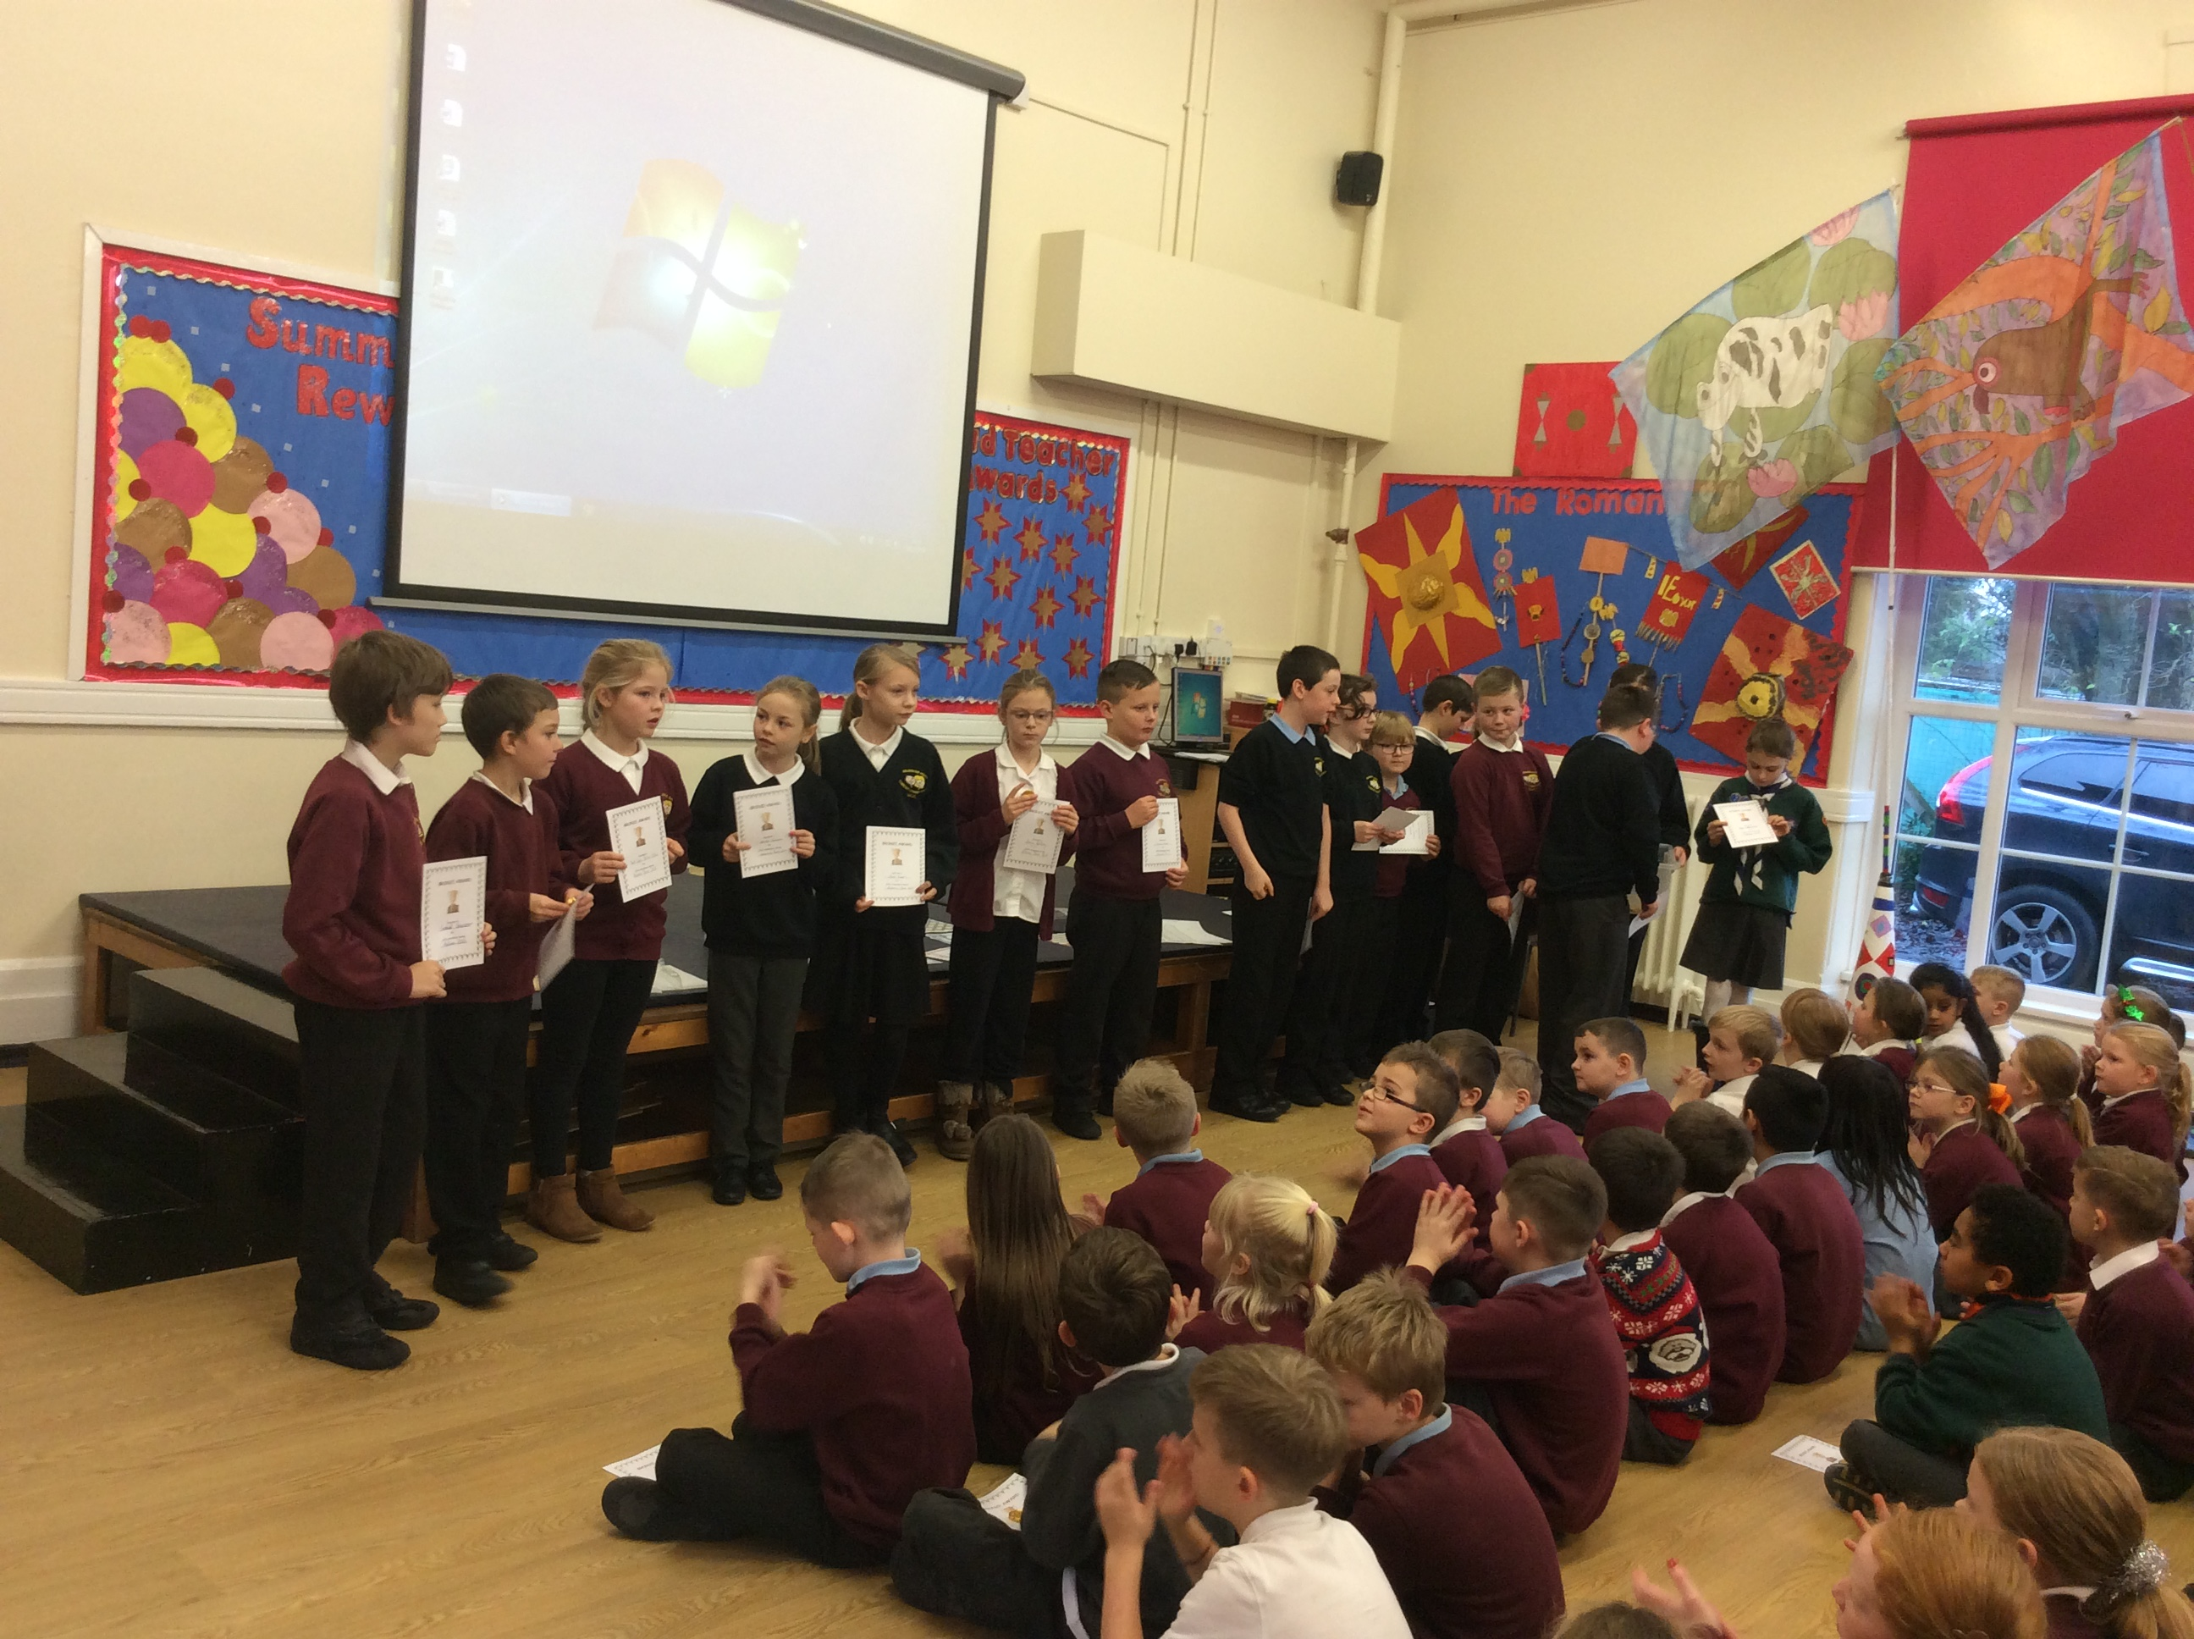
The Curriculum in Early Years Foundation Stage
In our Reception class and Nursery, every child’s education follows the recommendations of the Statutory Framework for Early Years Foundation Stage:
There are seven areas of learning and development. Three of these are particularly important and are known as prime areas: Communication and Language, Physical Development and Personal, Social and Emotional Development.
These three prime areas of learning are strengthened by our teaching in four other specific areas: Literacy, Mathematics, Understanding the World and Expressive Arts and Design.
Children are mainly given access to these areas of learning through various play opportunities which can be introduced by teachers or key-workers or may be introduced by the children themselves, Mathematics activities are underpinned by introducing the children to the “Numicon” scheme of practical Maths activities and resources.
As children become better equipped for more formal learning they may have access to key parts of the KS1 curriculum including our “Read, Write Inc” programme.

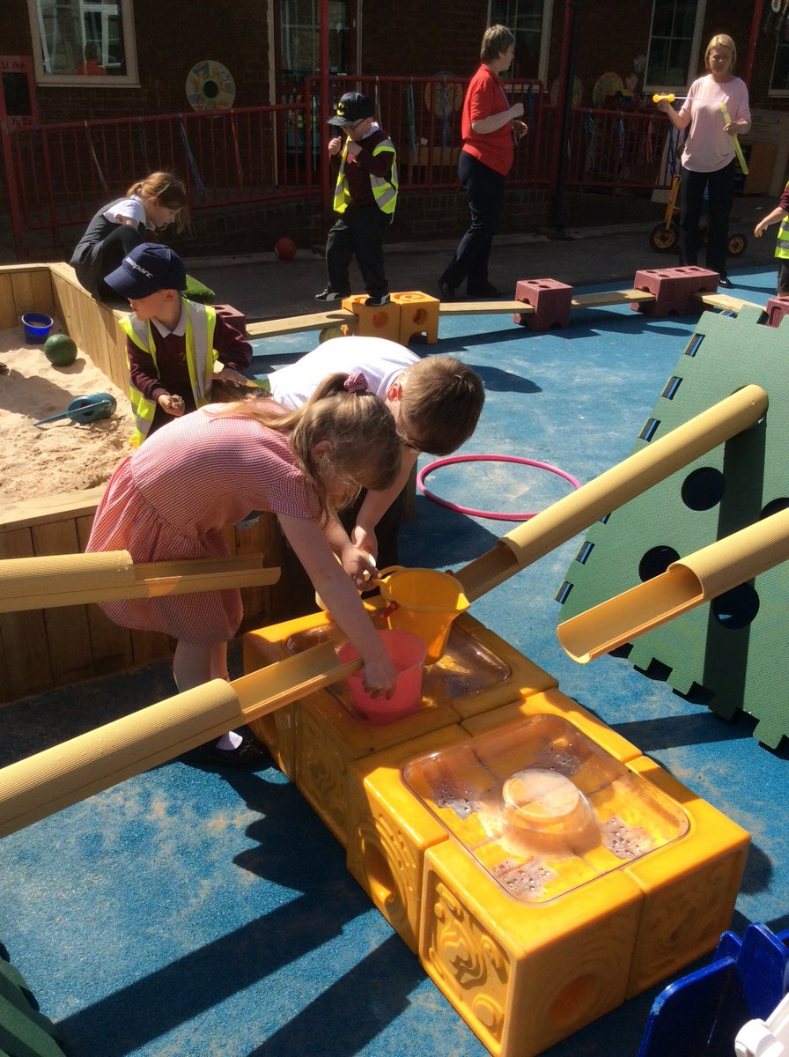
Our EYFS outdoor play area has role play areas, sand pits, garden areas and even a road for trikes and scooters!
Assessment
Children will be involved in statutory assessments at the end of Year One, Year Two and Year Six:
In Year One, this test is called phonics screening and is a check on the child’s ability to read using phonics. If a child does not achieve the required mark at their first attempt, they will then have access to further support and will re-take the test in June the following year.
In Year Two, teachers award an end of key stage assessment level for Reading, Writing and Maths. This level is informed by the child’s work within the class and by tests and tasks in Reading, Writing and Mathematics during their time in Year Two.
In Year Six, children take End-of-Key Stage National Tests in Reading, Mathematics and English skills (grammar, spelling and punctuation). Teachers also give children a level for writing based on work which takes place in the classroom.
Results of statutory assessments are reported to parents before the end of the summer term.
Teacher assessment takes place throughout the year using a variety of formal and informal techniques. This allows teachers to check children’s progress and ensure each pupil gets the appropriate level of support to help them progress.
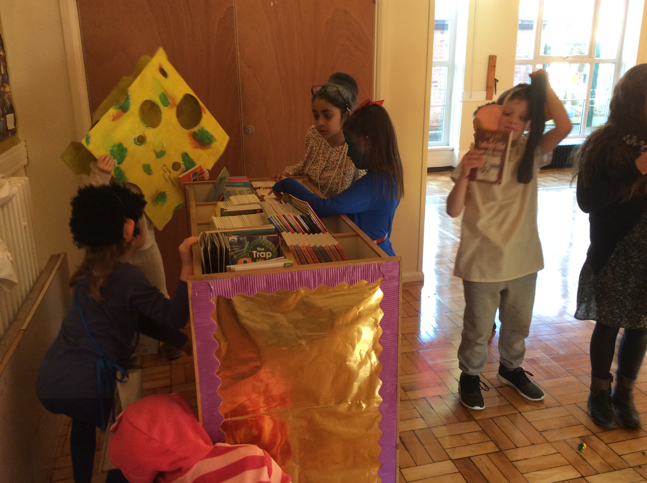

Special Educational Needs and Disabilities (SEND)
From the time children arrive in Billingham South Community Primary School, their progress is monitored and assessed. Where concern is raised about a pupil’s progress, either educationally or behaviourally, they may be placed on the SEN register.
Children who are placed on the SEND register will receive additional, or specialised, support to help them achieve their goals. Some children may receive this support in the way a teacher adapts their work; some may receive support through getting small group support with a teacher or teaching assistant; some may receive support on an individual basis with a special needs assistant or from an expert provided by an outside agency. Parents are involved from the earliest possible moment if a child is considered to have special educational needs.
The amount of time a child spends on the SEND register differs according to their need and the provision that has been made for them.
Where it is felt that a child needs additional, or specialist, support; the school’s SENCO will supervise the arrangements. The SENCO will liaise closely with staff and parents as well as monitor the progress of children.
The ultimate aim is to enable each child to participate as independently as possible in mainstream school.
If further concerns are expressed about a child’s progress after considerable support has already been given, the child may be put forward for an EHC (Education and Health Care Plan).
For further information on SEND please go to www.billinghamsouth.com to access our full SEND offer.

After School Clubs
The children at Billingham South have many opportunities to take part in activities. All our after-school clubs and opportunities encourage personal development and healthy competition is positively encouraged. Here are some of the extra-curricular activities that we offer:
Table Tennis
Anti-bulling Ambassadors
Digital Leaders
Football
Road Safety Quiz
Art Clubs and Competitions and events (including Stockton International Riverside Festival and Billingham International Folklore Festival)
Trampoline
Rugby
Netball
Annual musical and Shakespeare play as part of the Shakespeare Schools Festival
Transition Club
Brilliant Club (Durham University)
Fund Raising
Athletics
Music Lessons and Events
School Council
Home/School events through FOBS (Friends of Billingham South)
Gardening Activities (includes work with Billingham Environmental Link Group and Britain in Bloom)
Table Cricket
Art Club

School Attendance Information
If children are to achieve their full potential, they need to come to school on-time each day. Children who have a high rate of absence or are often late miss out on important educational opportunities.
For the same reasons, we ask all families to try to make sure that medical appointments are made outside of school hours and that family holidays are not taken during term time. Unfortunately, holidays in term time cannot be authorised except in exceptional circumstances and would appear on the register as an unauthorised absence. If you wish to notify school that your child will be taking a term-time holiday please visit the school office to collect a form.
This is particularly important during Year Six national tests as these tests cannot be retaken if a child misses them through absence.
Our school operates a “First Day Response” system to deal with absences. This is so that school and home can be assured that a child is not playing truant and it also helps school to improve its attendance figures.
If your child is going to be absent from school we ask you to notify the office by 9:30am.
If we do not receive a phone call from you, we will phone your home to enquire about the reason for the child’s absence.
If your child has a high rate of absence, you will receive a letter from school reminding you of the procedures for informing us of any absences. In the event, that the absence rate does not improve, we will seek to take further action in accordance with our school’s Attendance Policy
If absence rates do not improve after this point, you may be liable to a visit from Stockton’s School Attendance Officers or our school attendance officer who can take more formal action if it is required.
Excellent attendance is rewarded in our Celebration Assembly!
AN ATTENDANCE RATE OF BELOW 90% IS CLASSED AS PERSISTENT ABSENCE. ABSENCE FIGURES INCLUDE LATE ARRIVAL FOR LESSONS.

Illness and Emergencies
Should your child become ill or have an accident at school, it would be very important to contact you. Therefore, it is important that we have a current phone number.
When dealing with medical emergencies at school, it is vitally important that we have up to date information about your child’s health. Therefore, you must inform us of any medical conditions your child may have.
Children cannot cope happily with school if they are unwell. It’s also important to remember that some illnesses are highly contagious and it is not fair to send your child to school with an illness which other children could catch. If your child is feeling genuinely sick, it is important to keep them at home. Please read the guidelines below:
How many days to keep your child at home for common childhood ailments:
Vomiting 48 hours after last vomit
Diarrhoea 48 hours after diarrhoea has ended
Measles 4 days from onset of rash
Mumps Until swelling has gone down (5 days minimum)
German Measles 6 days from onset of rash
Chicken Pox 5 days from onset of rash
Impetigo Until skin is healed or 48 hours after starting antibiotics
Scabies Can return after starting treatment
Scarlet Fever Until 24 hours after starting antibiotics
Head Lice Return immediately after treatment

Medication

If medication has been prescribed by your child’s doctor to be taken 4 times a day, we will be happy to administer it at school. You must visit our school office and fill in a form which gives us permission to do so. Prescription medicines are stored in a lockable cabinet until required. Non-prescribed medicines are not allowed in school,

If your child has asthma, you must visit our school office and fill in an asthma form. You should then make sure your child has an inhaler in school which is clearly labelled. They will then be able to use this when necessary.

Behaviour Management

At Billingham South Community Primary School we offer an attachment aware trauma informed behaviour policy. We believe that good behaviour is a crucial factor in educational success. We encourage children to take responsibility for their own actions and make good choices. We aim to show them that all the choices they make about their behaviour have consequences.

Rewards
Rewards for good behaviour include: Receiving praise from a member of staff; stickers; Marvellous Me; sharing work with another member of staff; a certificate in celebration assembly, texts to parents and postcards sent home.

Sanctions
Sanctions for poor behaviour proceed down the list below. The order of the list may change depending on the severity of the incident or depending on the child requiring a more rigorous behaviour plan.

Reminder of the rules
Warning to make better choices
Isolation from the rest of the class on a table within the classroom
Losing playtime to continue classroom work
Sent to another classroom with work
Phone call from DHT/HT to parents to seek support with child’s behaviour.

School always seek the support of parents in dealing with poor behaviour choices. Initially this may take the form of a quick word at the end of school or a phone call. However, in certain circumstances a meeting between the school and parents may be necessary. Further sanctions, such as exclusion, can be found on our anti-bullying and behaviour policy.

School Values

At Billingham South we believe that a pupils’ attitude towards learning is crucial. We encourage a growth mindset through the promotion of five values.
Responsibility
Happiness
Quality
Courage
Resilience

As pupils display these values they can earn a values badge and eventually a sew on badge for their uniform.

Our Dress Code

We believe that our school should set high standards of dress and therefore we encourage all children to wear school uniform. By wearing school uniform, children will be able to identify with the school and feel part of our school community. All items of clothing should be clearly marked.

What should you wear?

Black or grey trousers/ shorts (tailored)
Black or grey skirt/ pinafore dress
White or pale blue shirt or blouse
White or sky blue polo shirt
Maroon School sweatshirt
V-neck maroon jumper or cardigan
Black school shoes (black boots can be worn from October half term until Easter)

In Year 6, children are encouraged to wear a black version of our school jumpers to make them feel more grown up and distinguish them as role models for younger children in the school.

What should you wear in Year 6?

Black trousers/ shorts (tailored)
Black skirt/ pinafore dress
White shirt or blouse
White polo shirt
Black school sweatshirt
V-neck black jumper or cardigan
Black school shoes

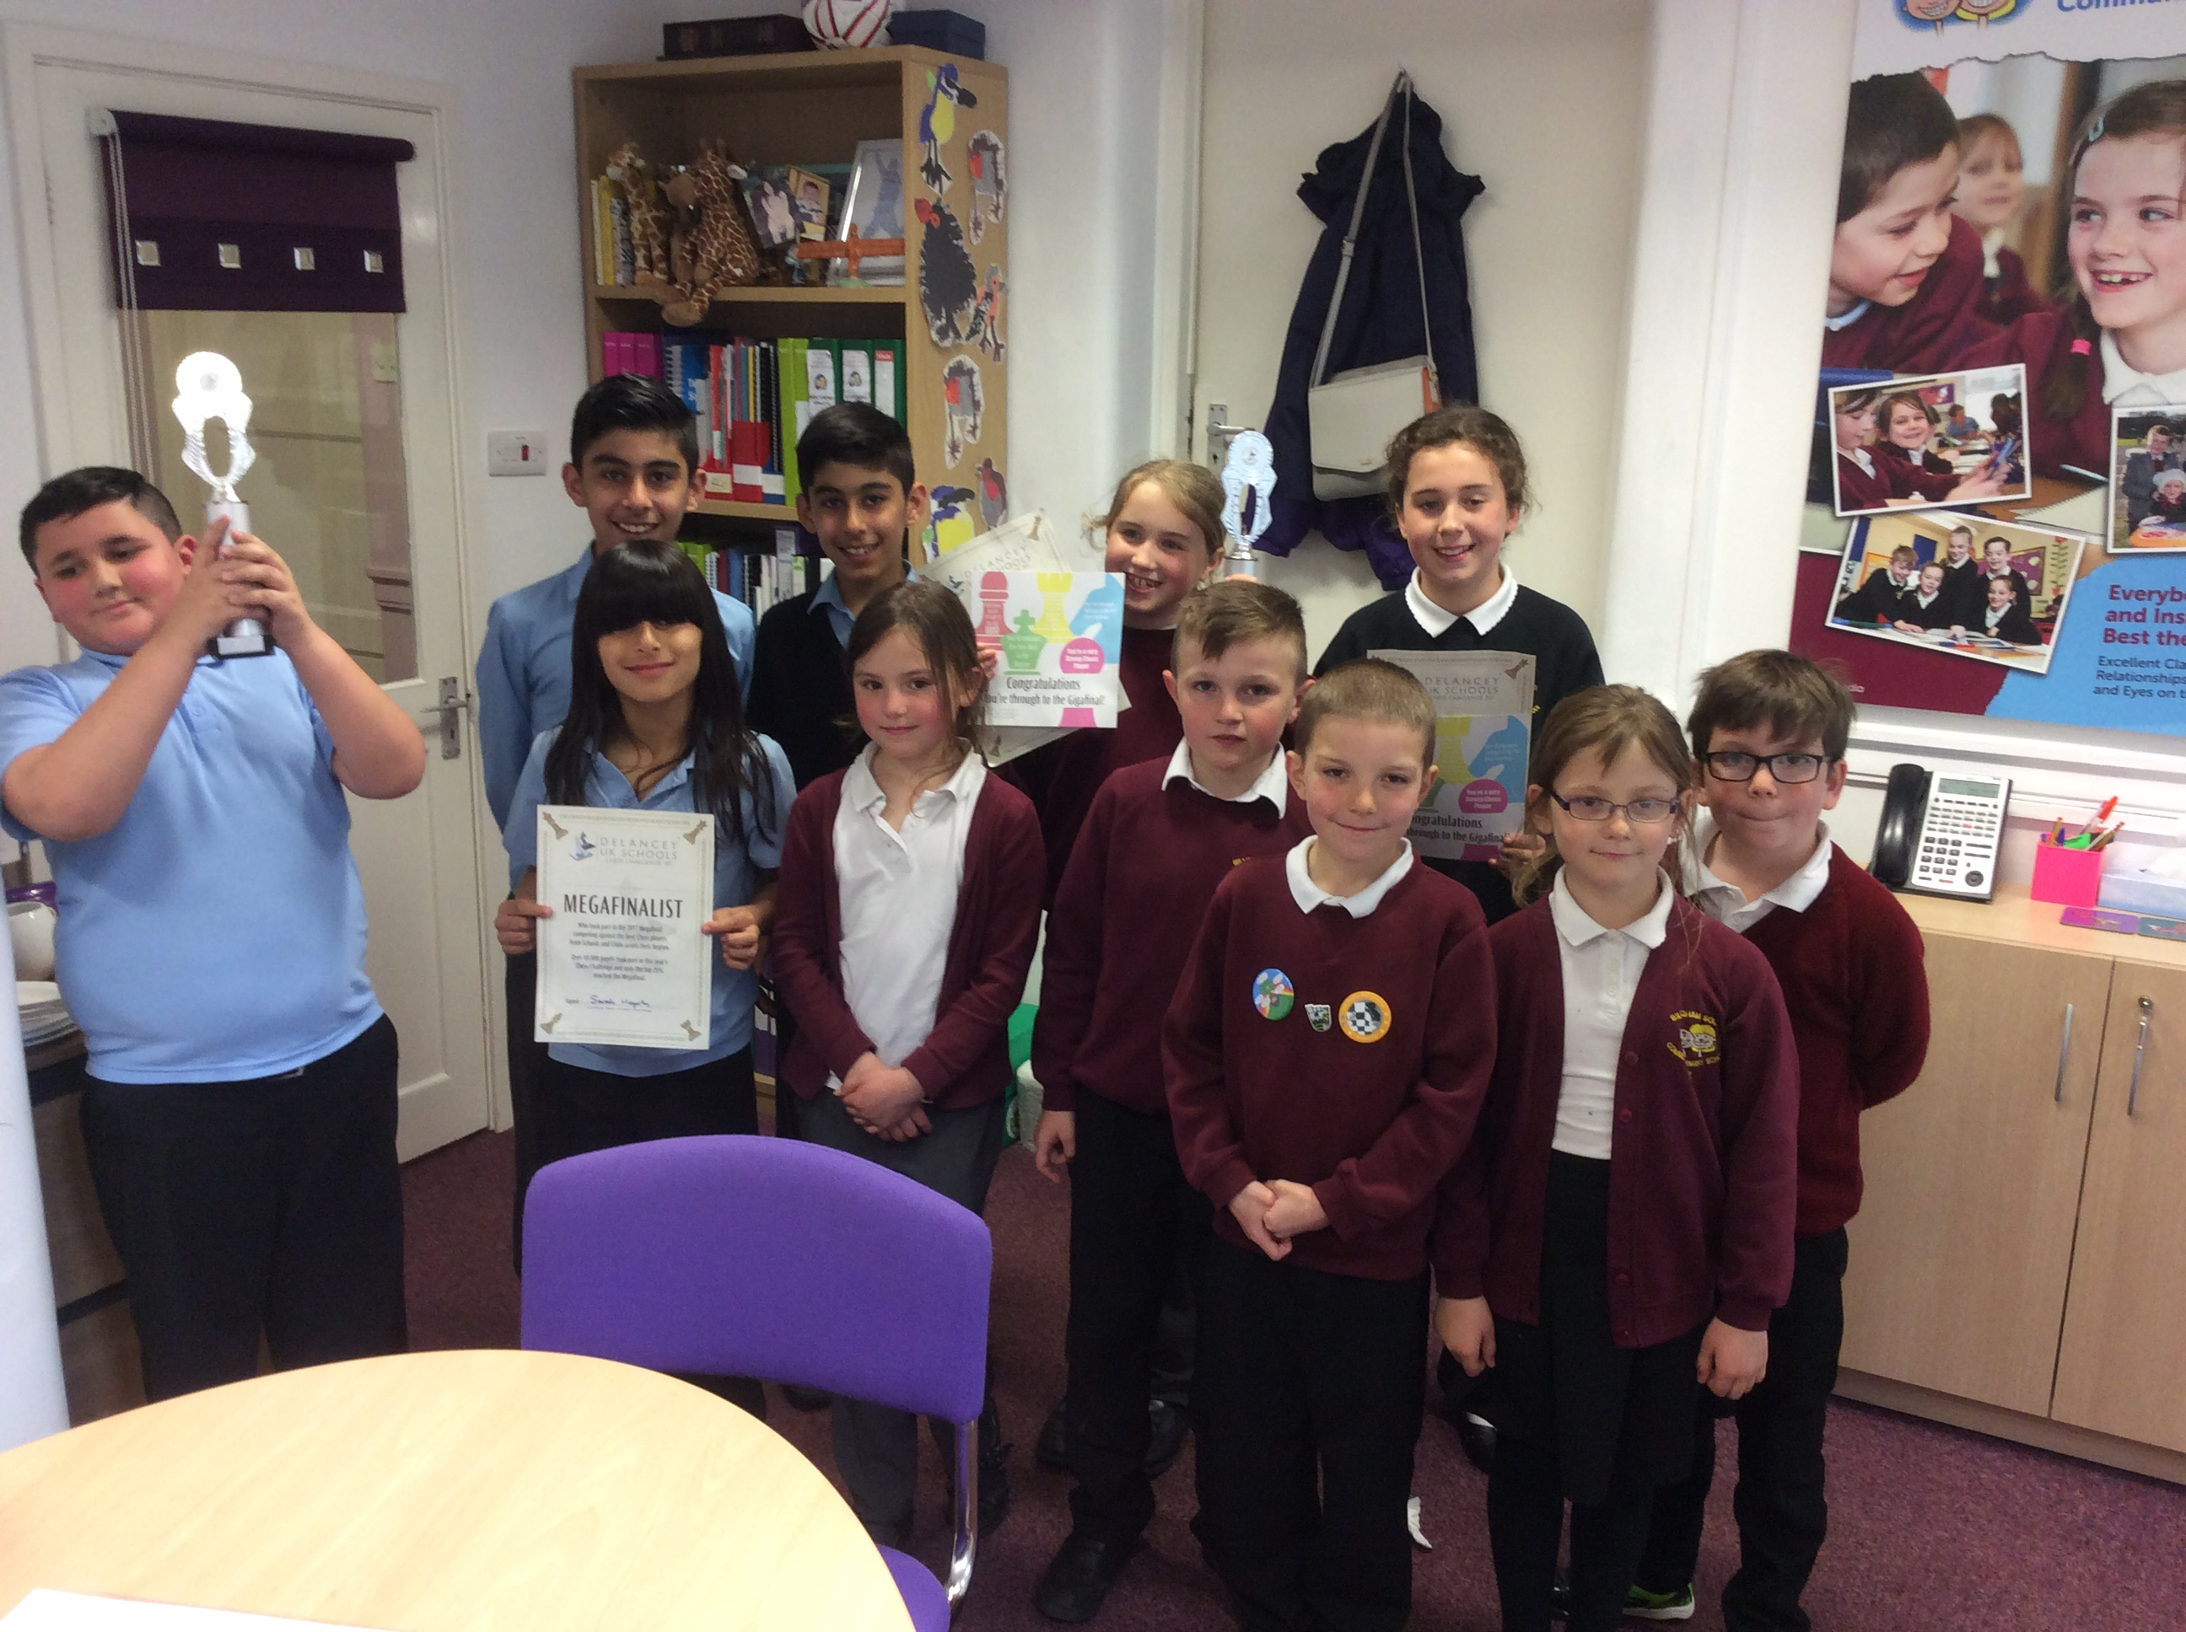

Children wearing examples of acceptable uniform

At Billingham South, P.E. lessons are compulsory. Parents asked to ensure that children wear appropriate PE kit to school.

What should you wear for P.E.?

Indoor P.E. Outdoor P.E.
White Crew Neck T-Shirt | The same as indoors but children may wear a plain black tracksuit.
Black Shorts
White Socks
Plimsolls | Trainers

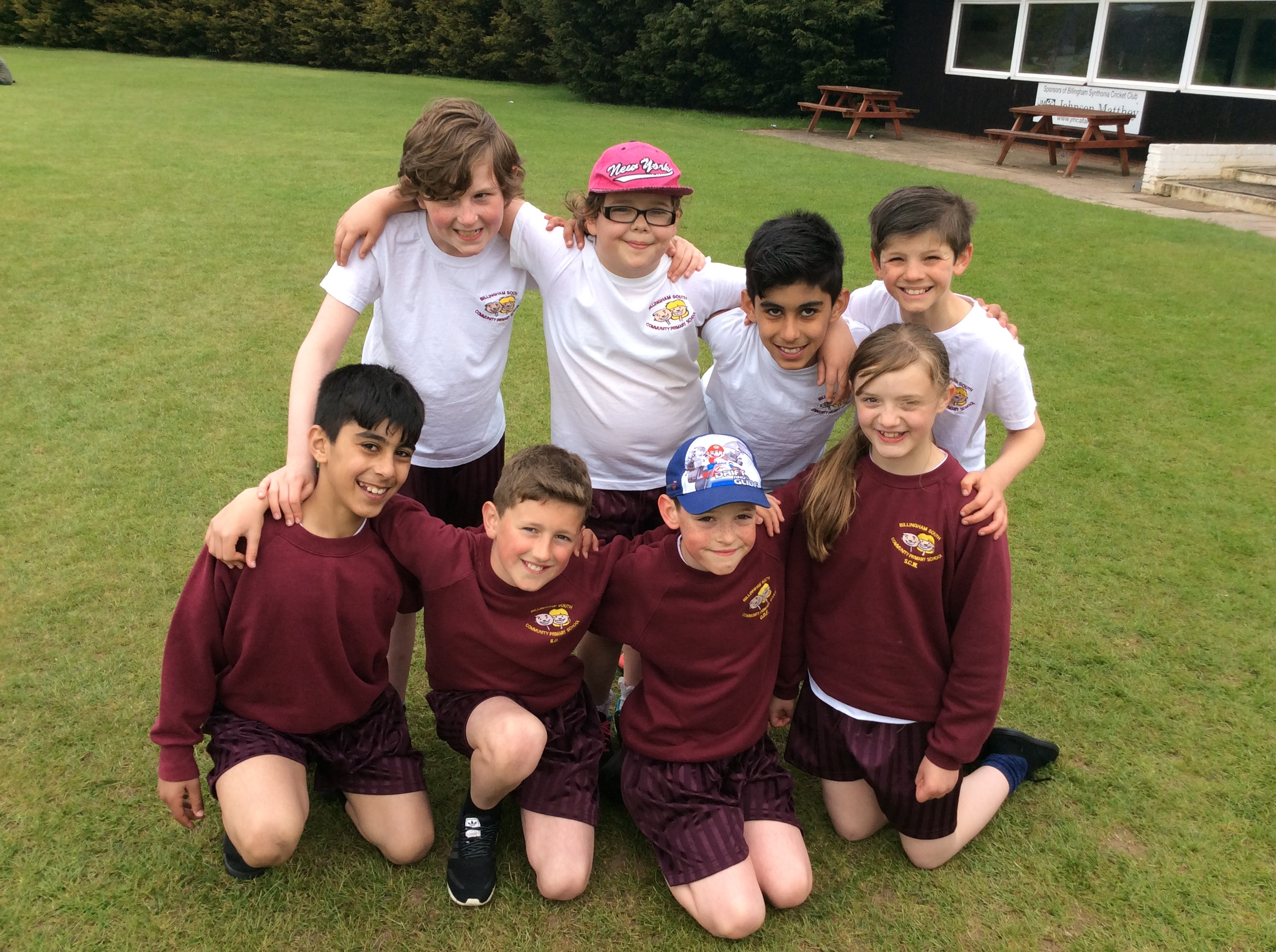

Please Note – For swimming sessions, boys must wear proper swimming trunks (not sports shorts or Bermuda shorts) and girls should wear one piece costumes (no bikinis). Long hair must be tied back during swimming sessions

Parents are reminded that the following are not acceptable as part of our school dress code:

1) Jewellery, other than one set of small studs in pierced ears and/or wristwatches.

2) Outlandish or patterned hairstyles eg: shaved or partially shaved names or logos shaved into hair and hair extensions.

3) Make up including fake nails.

Lost Property

In a large school, it is inevitable that children’s property is sometimes mislaid or lost. When we find lost property it is put in one of our lost property boxes which are located in different areas around school.

We ask that parents label all items of children’s clothing clearly. While this doesn’t guarantee that items will be returned, it is easier to return labelled items.

Playground Rules for Everyone

No Smoking

In accordance with national government policy which forbids smoking in certain public places, our school is a no-smoking area. We respectfully ask that nobody smokes cigarettes or e-cigarettes on our school premises.

Dogs

No dog is allowed on our school premises except for Guide Dogs accompanying visually impaired people.

Bicycles

We encourage children to cycle to school. In Year Five children will take their Level One and Two cycle training. Once a child has completed this training, they may cycle to school unaccompanied. Before this point, children may only cycle if accompanied by an adult.

Playground Equipment

We have lovely playground equipment (Fort Henry, a Pirate Ship and a MUGA). These are for use of all our children during the school day. They must not be used by anyone when a member of staff is not present.

Anyone who rides a bike or scooter to school must dismount before they enter the premises. Bicycles and scooters must be parked safely within designated cycle bays. All bicycles and scooters are parked at the owner’s risk – school do not take responsibility for any damage or theft. If we find cycles or scooters on the premises parked somewhere other than the cycle bays, they will be placed somewhere safe until the owner re-claims them from the school office.

Pupil Premium

All schools receive extra money from the government for pupils from families where a parent is in the armed forces; for children in care and for pupils who are entitled to Free School Meals. We ask all parents who believe they are entitled to Free School Meals to visit the school office. This means that school will be able to claim extra funding towards the education of the children.

Mobile Phones, Sweets and Other Valuables

Children should not bring mobile phones or valuables to school. If a child does bring such an item to school, they should hand it in to the school office for safe-keeping immediately. It will be returned at the end of the school day. However, school take no responsibility for loss or damage to the item.

Complaints, Concerns or Praise

It is sincerely hoped that if you have concerns about any aspects of school life, you would immediately approach a member of staff to discuss it. It is always best to call in and sort out small problems before they become a big worry. We have friendly and open staff who are always happy to listen. Our Head Teacher and Deputy Head Teacher always take any parental concerns very seriously and are happy to make time to discuss such matters.

Likewise, please let school know if you are particularly pleased with us for any reason. Parents can give any feedback they want to share through our questionnaires on parents evening or through the “Parent View” tab on our school website.

